[Intel® RealSense™ Computer Vision - Depth and Tracking cameras (intelrealsense.com)](https://www.intelrealsense.com/)

中文官方

[开始使用英特尔® 实感™ 追踪摄像头 (intelrealsense.com)](https://www.intelrealsense.com/zh-hans/get-started-tracking-camera/)

以下链接包含基于英特尔 D435i SLAM ROS 教程的指南。

<https://shinkansan.github.io/2019-UGRP-DPoom/SLAM>

在指南标题为**“使用 rtabmap 进行定位”**的部分中，它建议使用**软件 RTABMAP** 研究记录的点云映射文件并从该地图中获取相对位置。

英特尔的 D435i SLAM 指南在这里：

<https://github.com/IntelRealSense/realsense-ros/wiki/SLAM-with-D435i>

[(53条消息) 我感觉D435i的使用有必要写出一篇教程，什么烧写升级固件，更改分辨率帧率，标定，发布IMU数据等等_TYINY的博客-CSDN博客](https://blog.csdn.net/sinat_16643223/article/details/118959961)

[(53条消息) 如何用Realsense D435i运行VINS-Mono等VIO算法 获取IMU同步数据_vins-mono没有imu可以跑吗_Manii的博客-CSDN博客](https://blog.csdn.net/qq_41839222/article/details/86552367)

[RealSenseD435i （四）：运行 VINS-mono代码 - 代码天地 (codetd.com)](https://www.codetd.com/article/13487318)

相机接口APII

[Intel® RealSense™ Cross Platform API: Class List (intelrealsense.github.io)](https://intelrealsense.github.io/librealsense/doxygen/annotated.html)

[基于深度相机 RealSense D435i 的 ORB SLAM 2 - 简书 (jianshu.com)](https://www.jianshu.com/p/9e3d31ba35da)

[操作方法：从 D435i 和 T265 获取 IMU 数据 – 英特尔®实感™深度和跟踪摄像头 (intelrealsense.com)](https://www.intelrealsense.com/how-to-getting-imu-data-from-d435i-and-t265/)

相机宏定义

<https://intelrealsense.github.io/librealsense/doxygen/rs__sensor_8h.html#ae04b7887ce35d16dbd9d2d295d23aac7>

[“帧未到达 15000”异常 ·问题 #7376 ·英特尔实感/自由实感 (github.com)](https://github.com/IntelRealSense/librealsense/issues/7376)

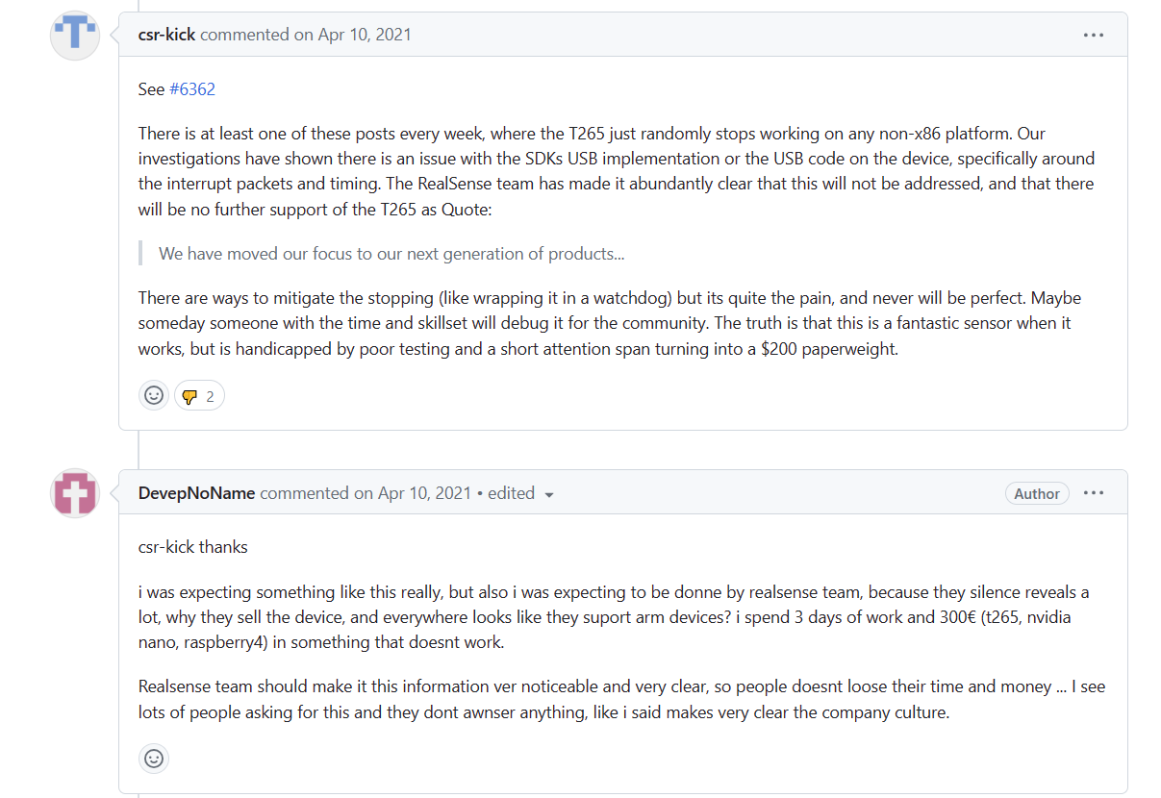

arm架构似乎无法解决这个bug

[Raspberry Pi 4 VL805 firmware release 0138a1 - Page 3 - Raspberry Pi Forums](https://forums.raspberrypi.com/viewtopic.php?p=1855178&hilit=T265#p1857180)

[Problems using T265 with Pi 4 – Intel RealSense Help Center](https://support.intelrealsense.com/hc/en-us/community/posts/360044038933-Problems-using-T265-with-Pi-4)

姿态解算

https://www.cnblogs.com/WangHongxi/p/12357230.html

imu六轴算法

https://www.bilibili.com/video/BV1DE411c7ww/?spm_id_from=333.337.search-card.all.click&vd_source=fc1cba0aec564f49467a30f6ff80d275

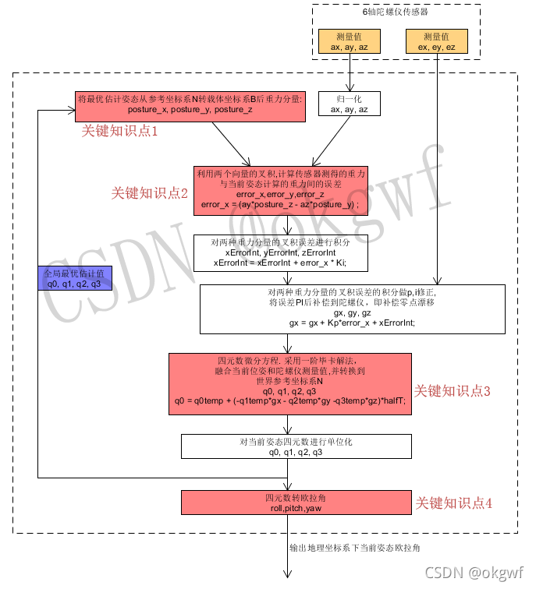

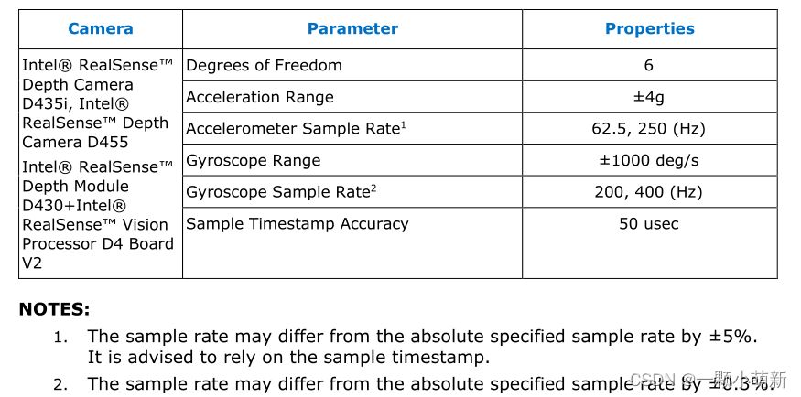

相机imu数据

https://blog.csdn.net/qq_30150579/article/details/127157697

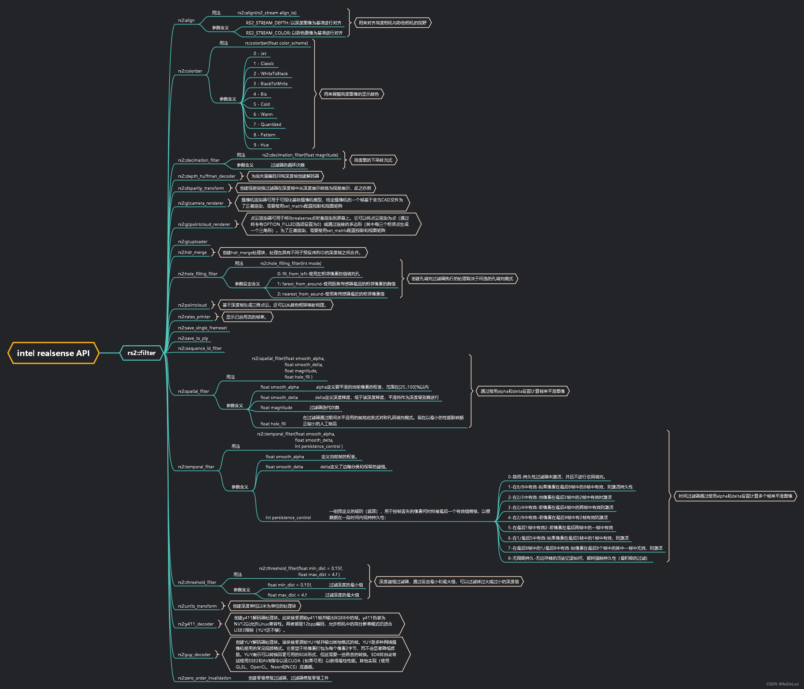

IntelRealense c++ code examples

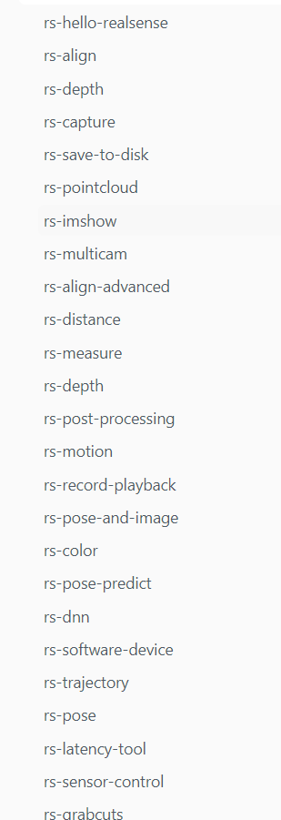

1．rs-hello-realsense

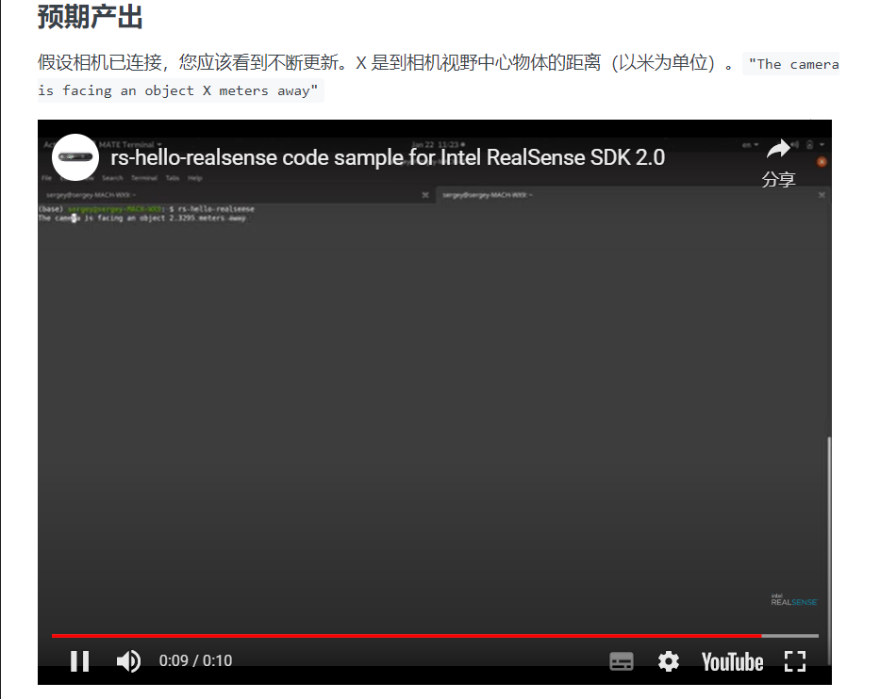

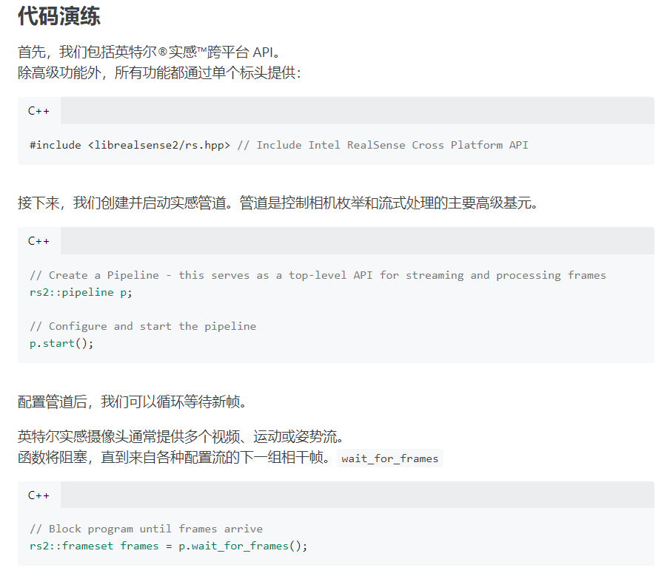

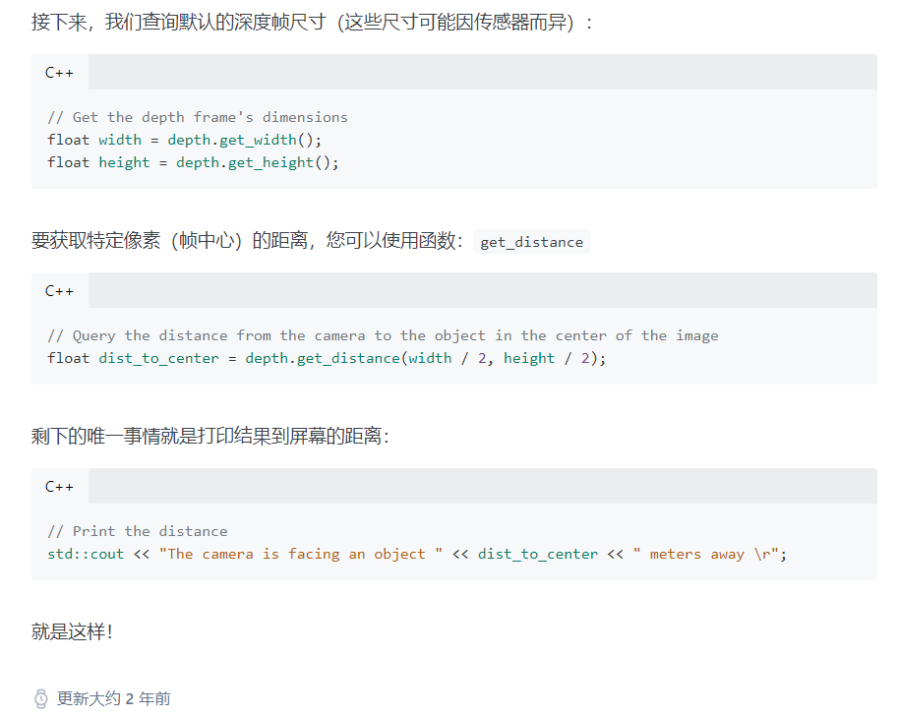

2. rs-align

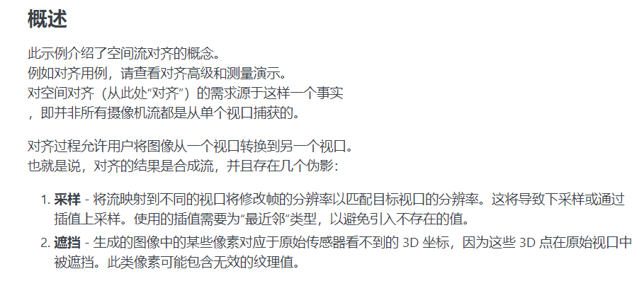

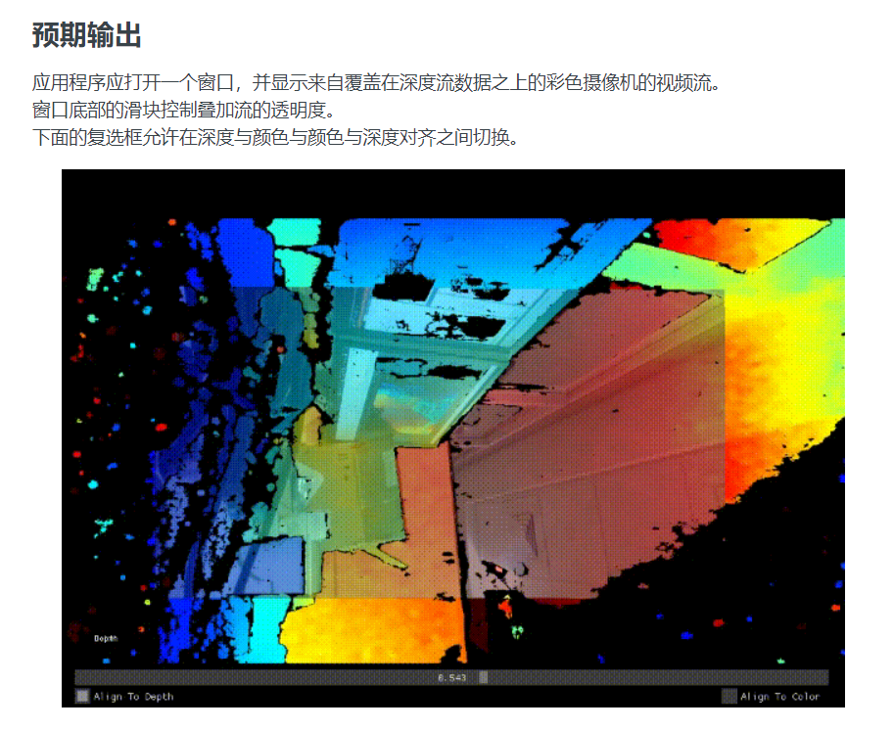

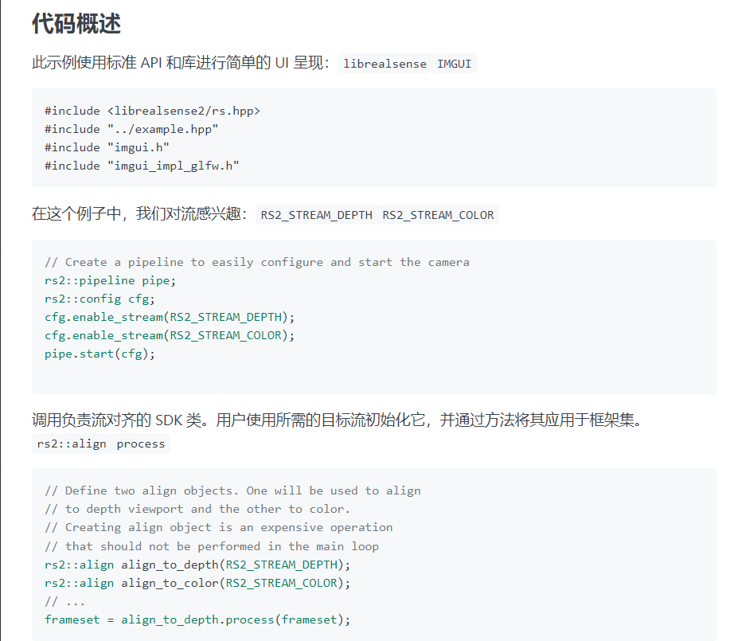

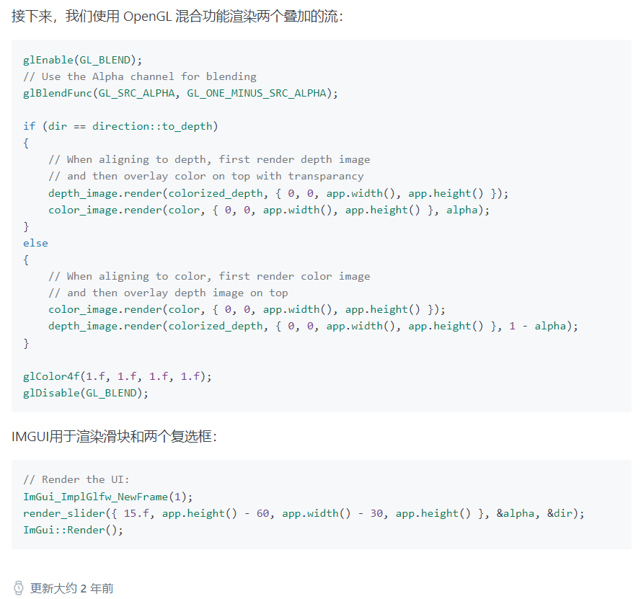

3、rs-capture

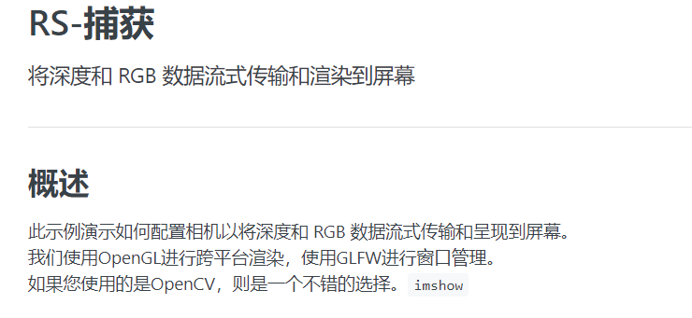

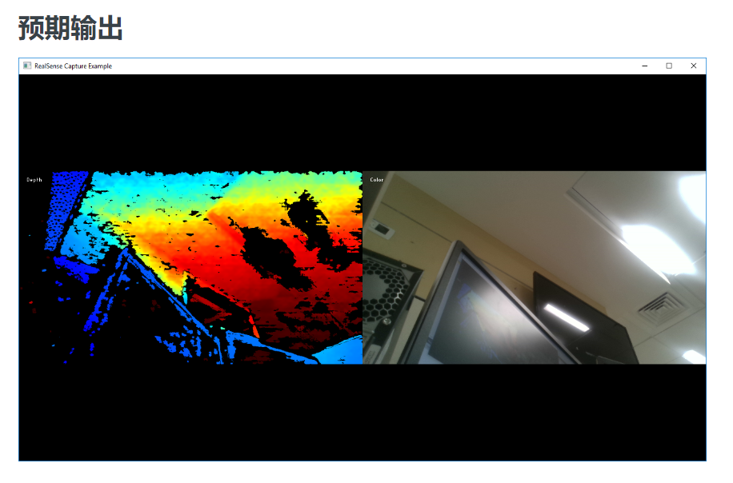

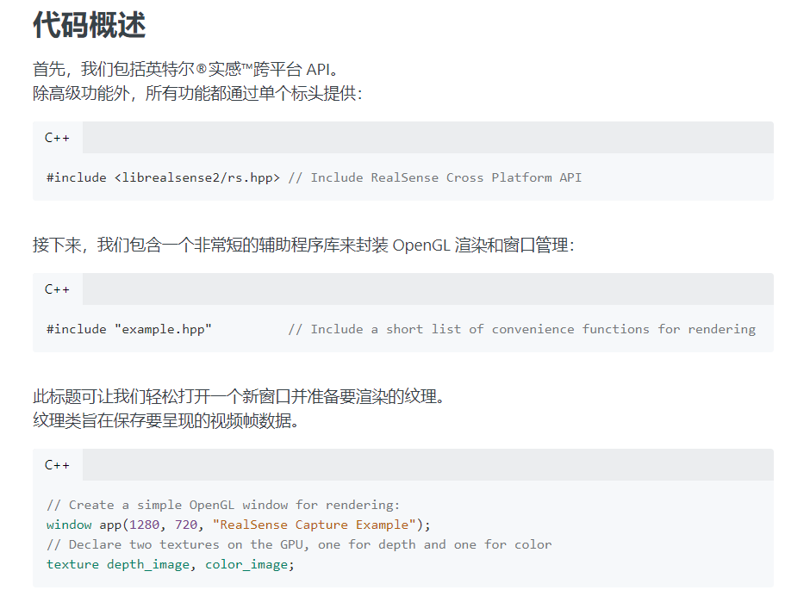

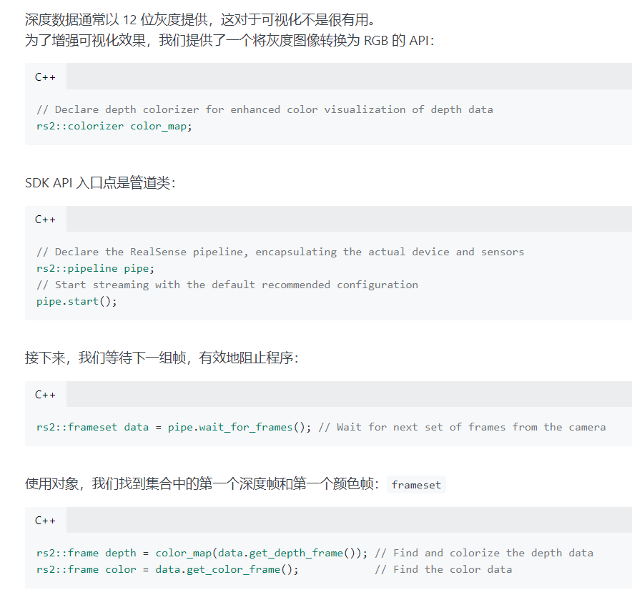

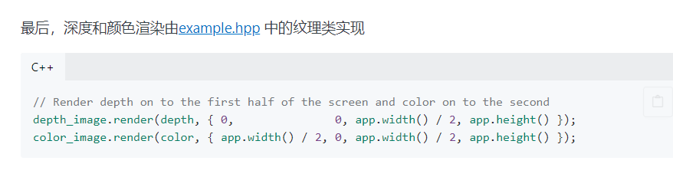

# 4、rs-save-to-disk

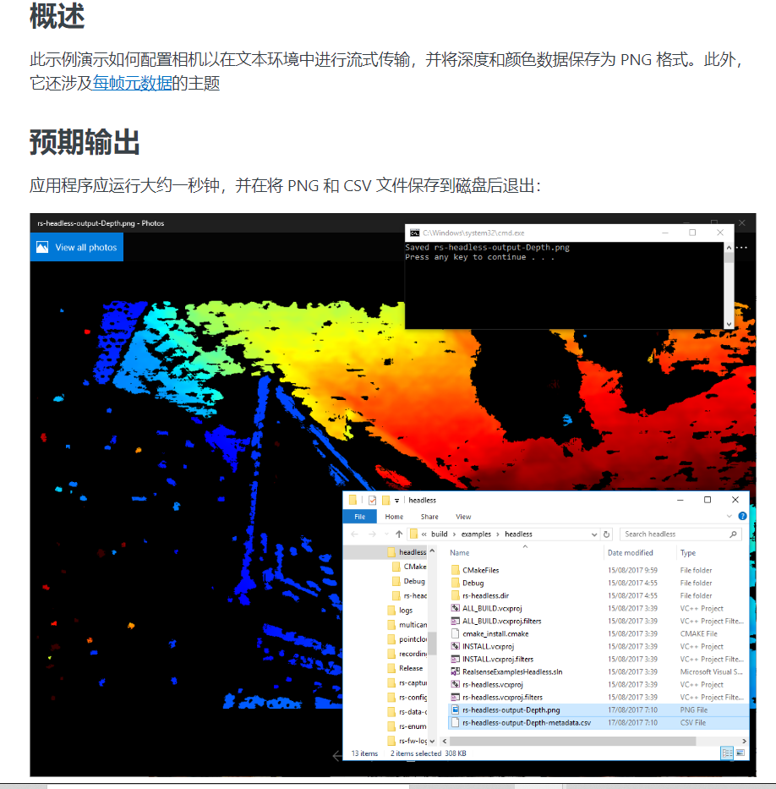

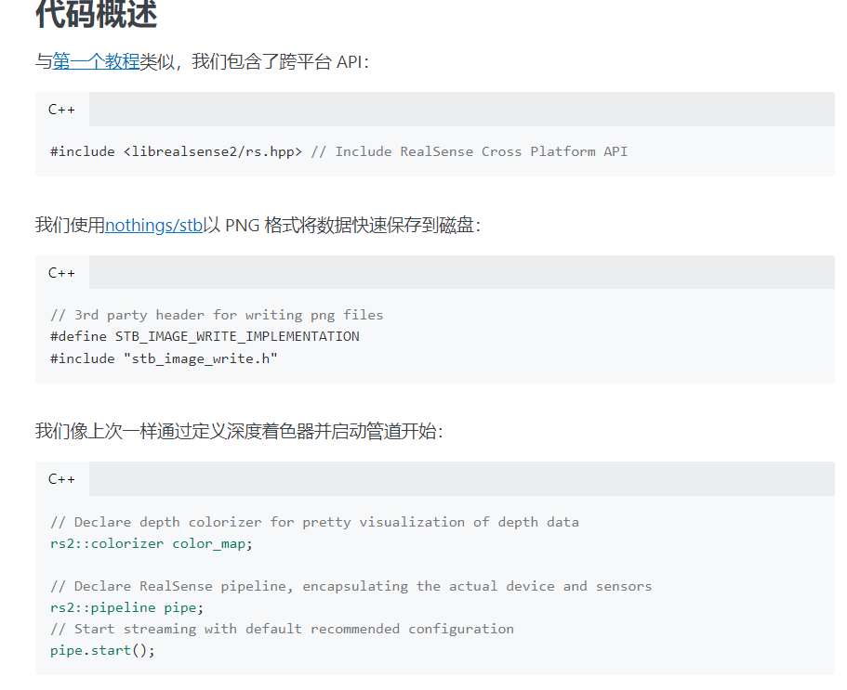

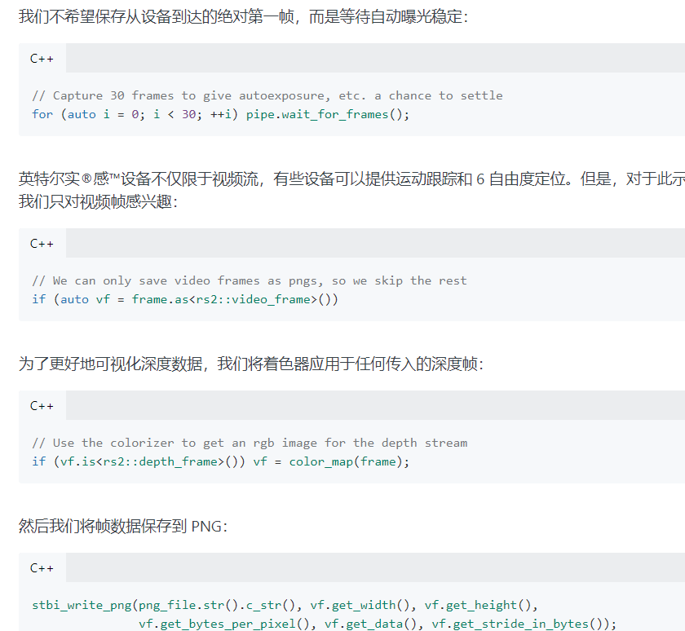

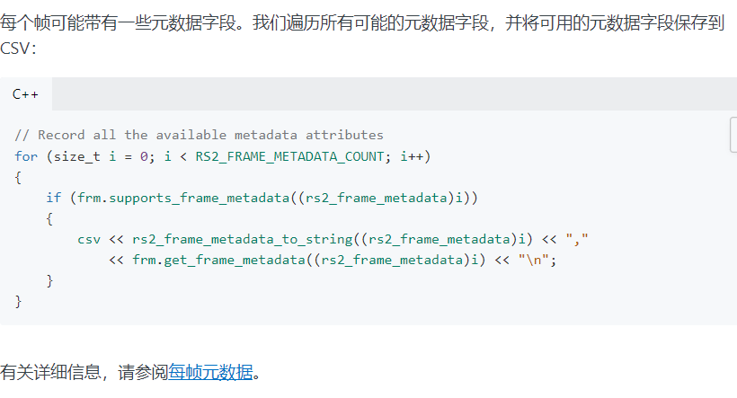

5、rs-pointcloud

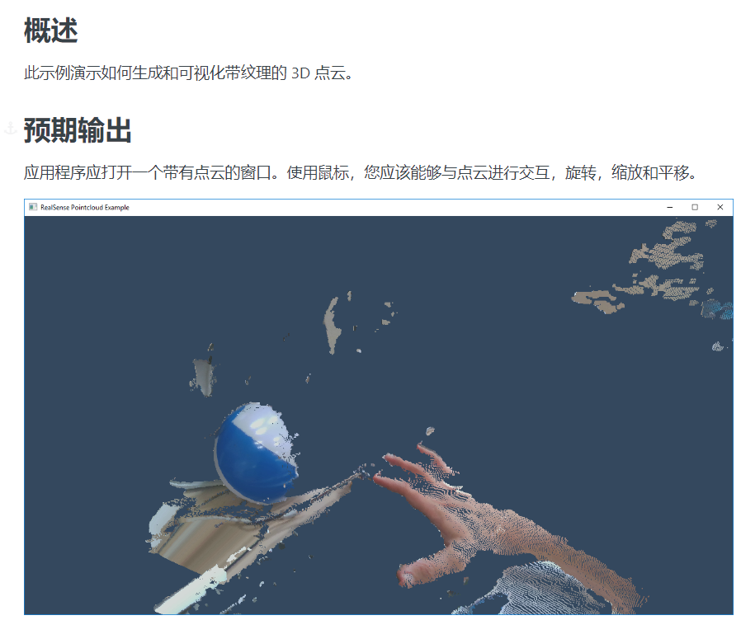

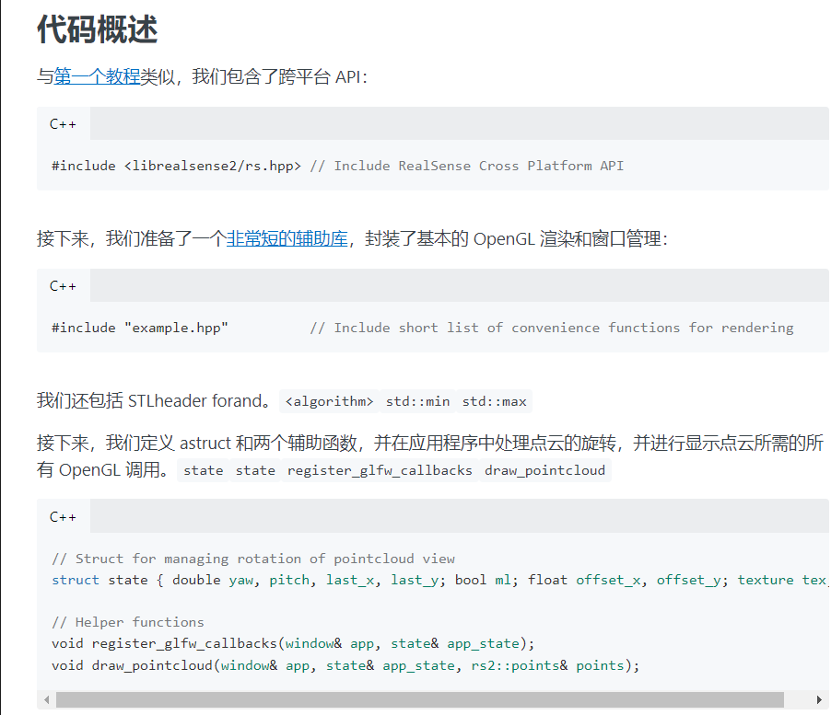

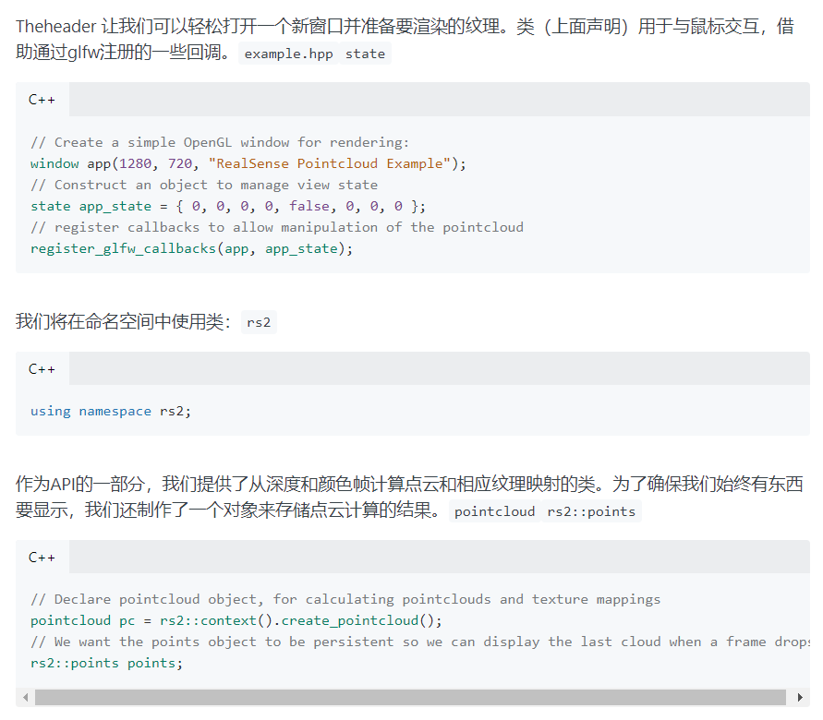

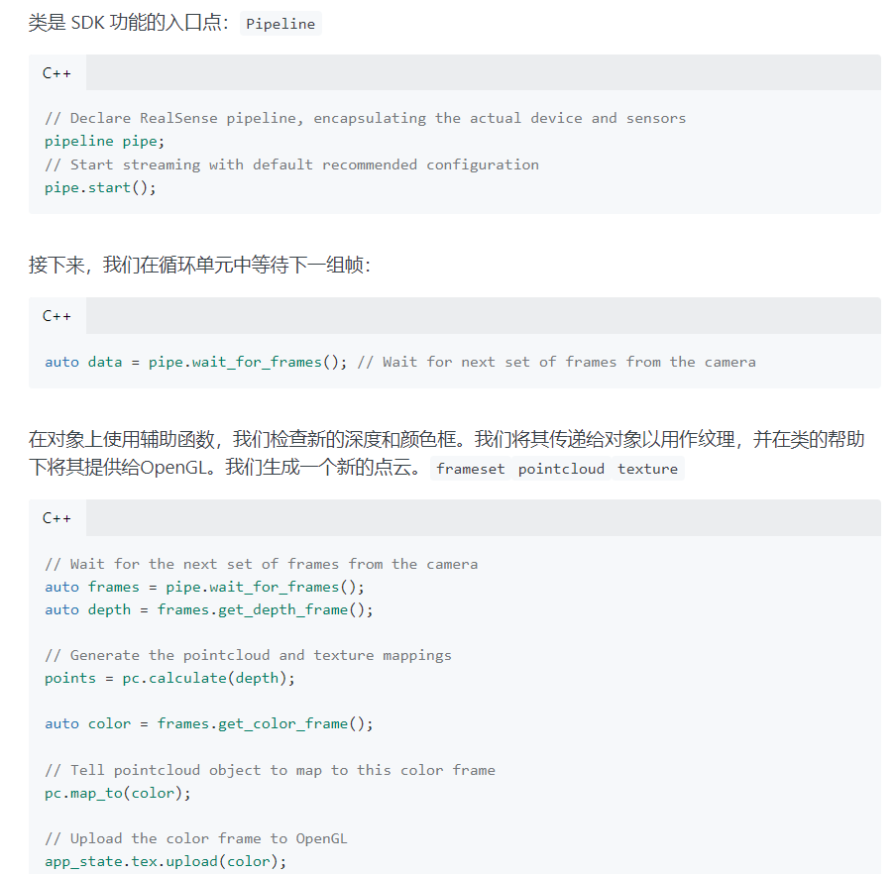

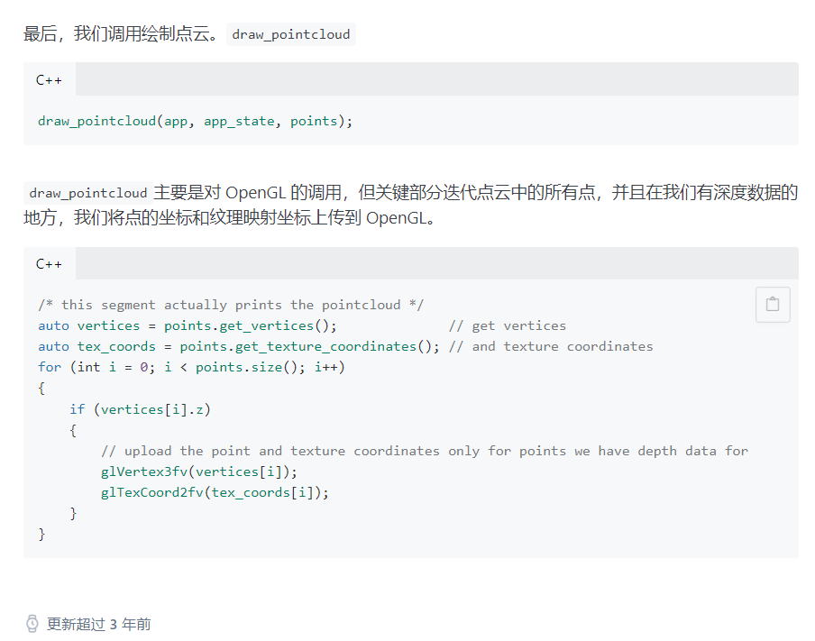

6、rs_opencv_imshow

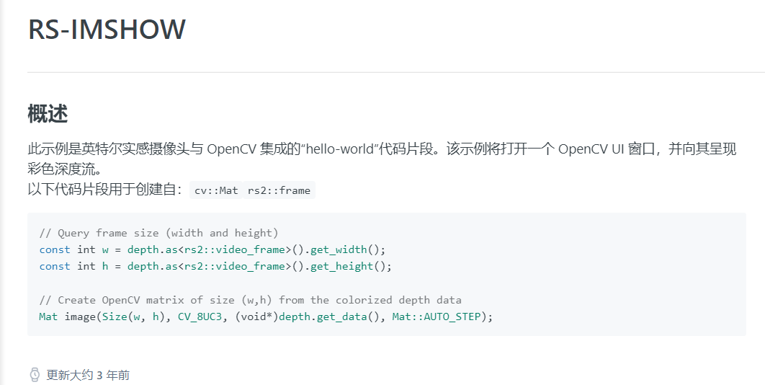

7、rs-align-advanced

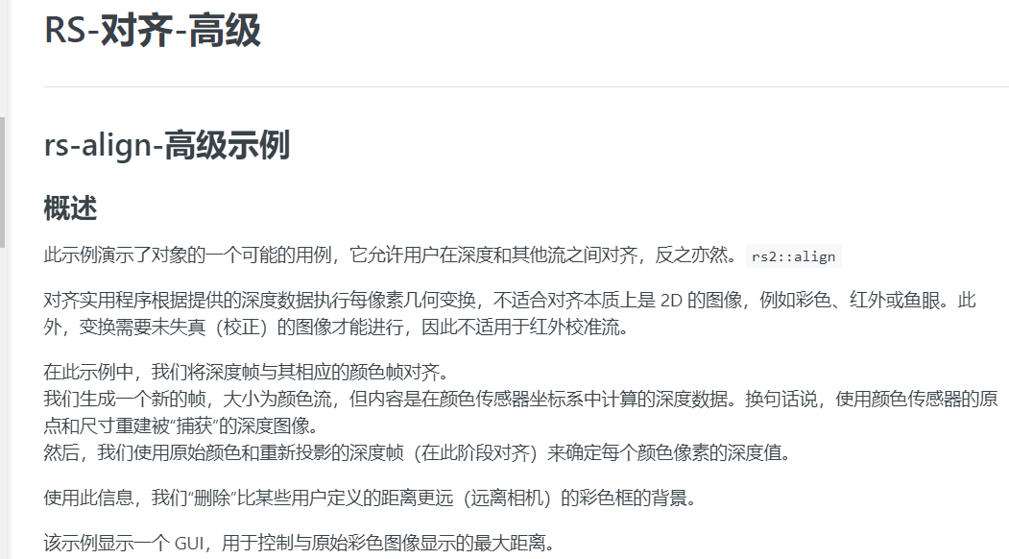

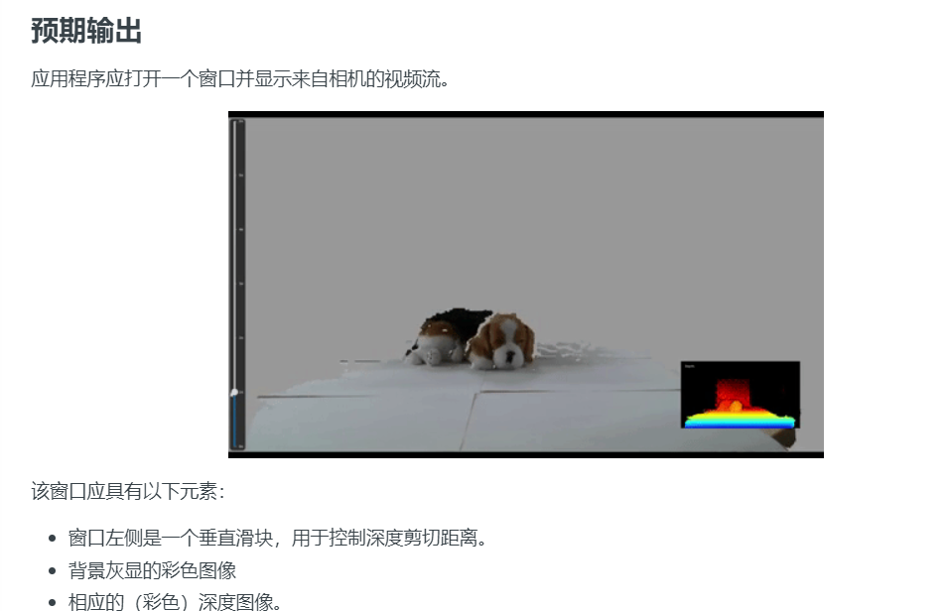

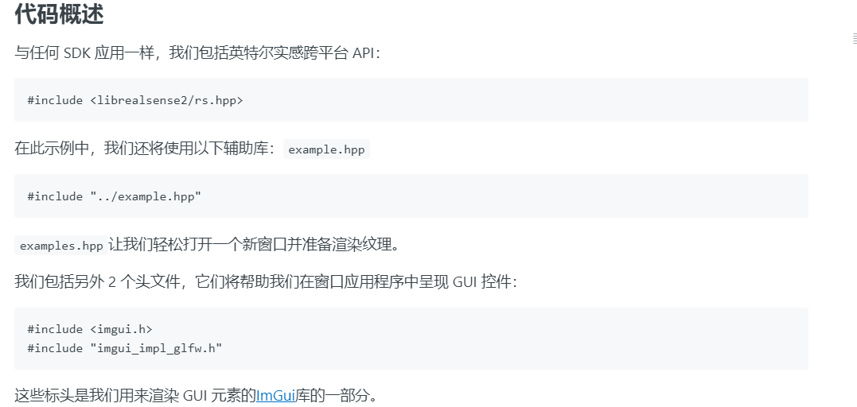

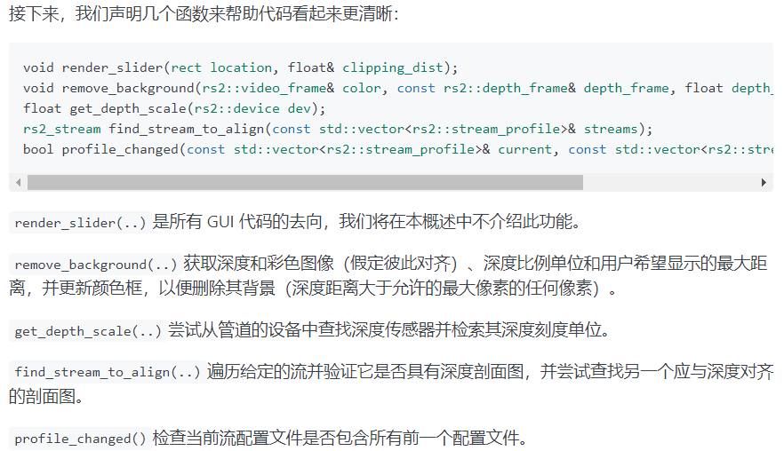

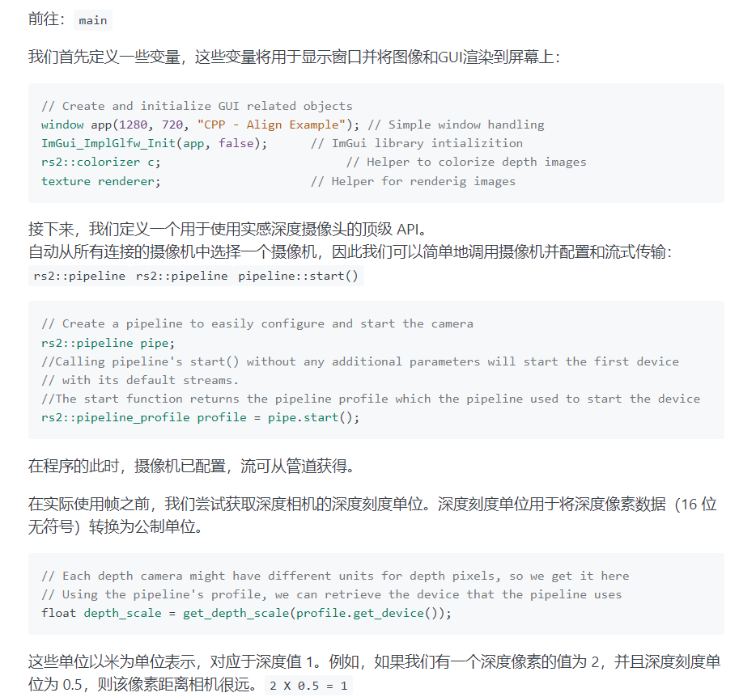

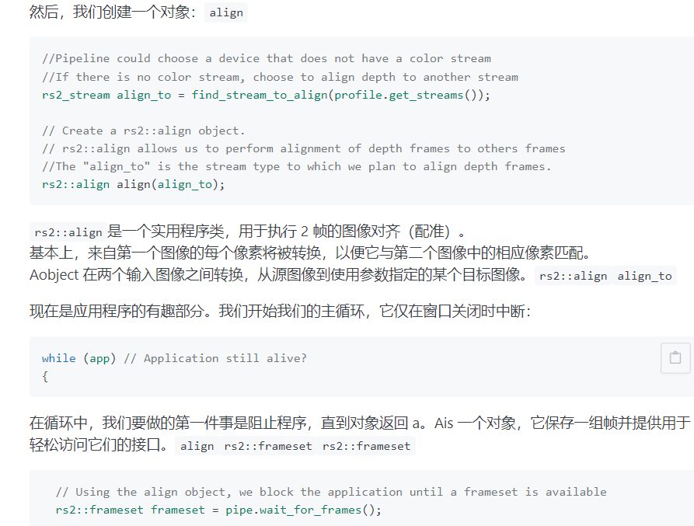

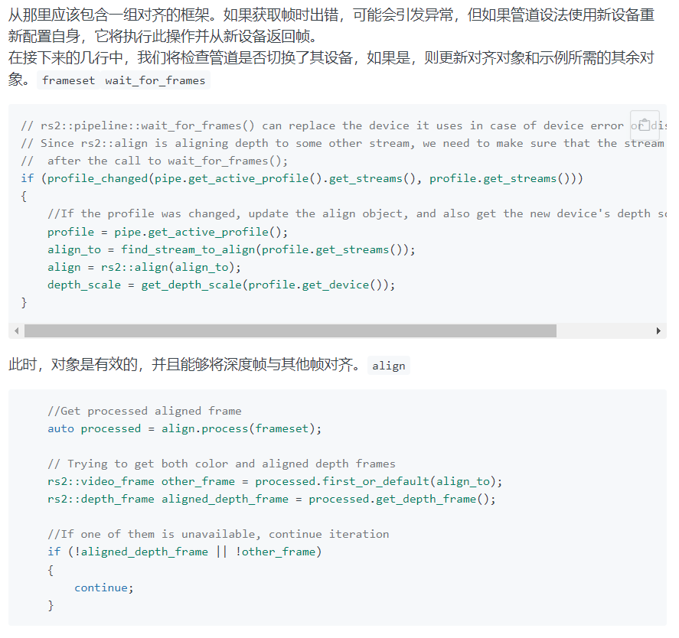

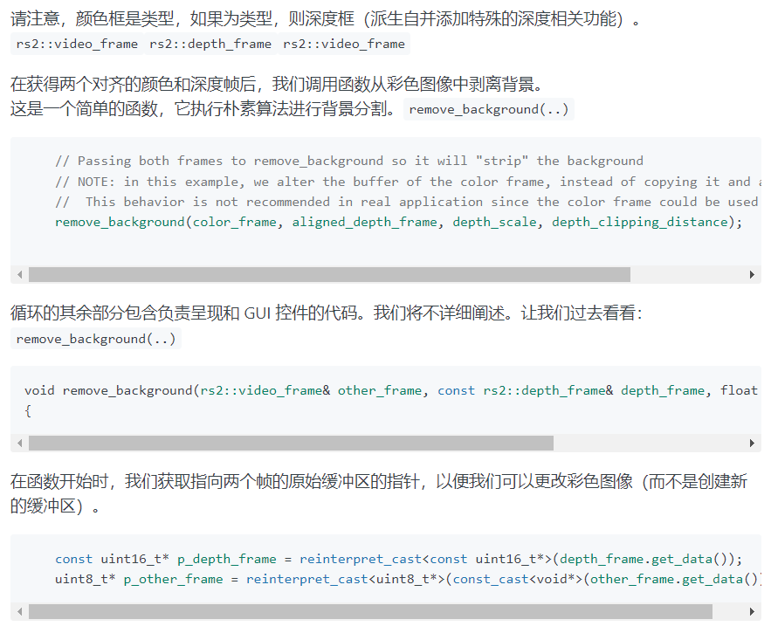

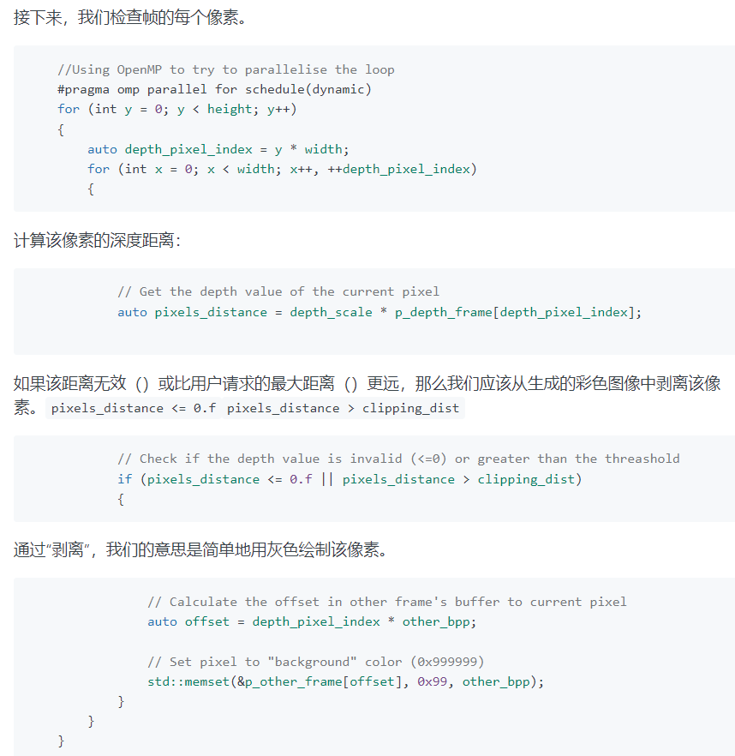

8、re_distance

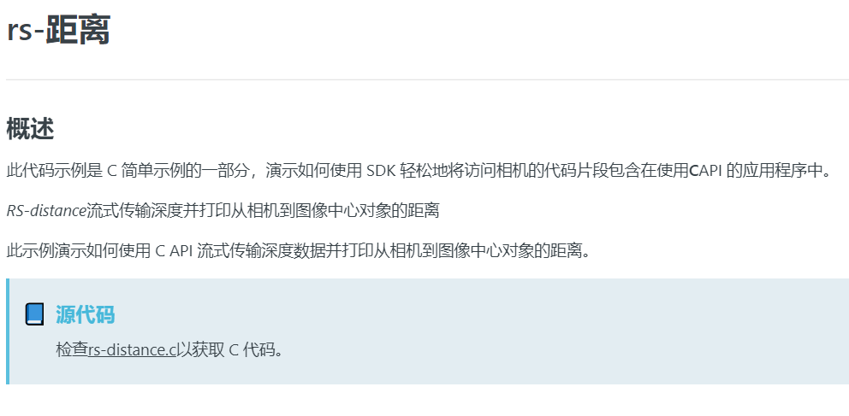

// License: Apache 2.0. See LICENSE file in root directory.

// Copyright(c) 2017 Intel Corporation. All Rights Reserved.

/* Include the librealsense C header files */

#include <librealsense2/rs.h>

#include <librealsense2/h/rs_pipeline.h>

#include <librealsense2/h/rs_option.h>

#include <librealsense2/h/rs_frame.h>

#include "example.h"

#include <stdlib.h>

#include <stdint.h>

#include <stdio.h>

////////////////////////////////////////////////////////////////////////////////////////////////////////////////////

// These parameters are reconfigurable //

////////////////////////////////////////////////////////////////////////////////////////////////////////////////////

#define STREAM RS2_STREAM_DEPTH // rs2_stream is a types of data provided by RealSense device //

#define FORMAT RS2_FORMAT_Z16 // rs2_format identifies how binary data is encoded within a frame //

#define WIDTH 640 // Defines the number of columns for each frame or zero for auto resolve//

#define HEIGHT 0 // Defines the number of lines for each frame or zero for auto resolve //

#define FPS 30 // Defines the rate of frames per second //

#define STREAM_INDEX 0 // Defines the stream index, used for multiple streams of the same type //

////////////////////////////////////////////////////////////////////////////////////////////////////////////////////

int main()

{

rs2_error* e = 0;

// Create a context object. This object owns the handles to all connected realsense devices.

// The returned object should be released with rs2_delete_context(...)

rs2_context* ctx = rs2_create_context(RS2_API_VERSION, &e);

check_error(e);

/* Get a list of all the connected devices. */

// The returned object should be released with rs2_delete_device_list(...)

rs2_device_list* device_list = rs2_query_devices(ctx, &e);

check_error(e);

int dev_count = rs2_get_device_count(device_list, &e);

check_error(e);

printf("There are %d connected RealSense devices.\n", dev_count);

if (0 == dev_count)

return EXIT_FAILURE;

// Get the first connected device

// The returned object should be released with rs2_delete_device(...)

rs2_device* dev = rs2_create_device(device_list, 0, &e);

check_error(e);

print_device_info(dev);

// Create a pipeline to configure, start and stop camera streaming

// The returned object should be released with rs2_delete_pipeline(...)

rs2_pipeline* pipeline = rs2_create_pipeline(ctx, &e);

check_error(e);

// Create a config instance, used to specify hardware configuration

// The retunred object should be released with rs2_delete_config(...)

rs2_config* config = rs2_create_config(&e);

check_error(e);

// Request a specific configuration

rs2_config_enable_stream(config, STREAM, STREAM_INDEX, WIDTH, HEIGHT, FORMAT, FPS, &e);

check_error(e);

// Start the pipeline streaming

// The retunred object should be released with rs2_delete_pipeline_profile(...)

rs2_pipeline_profile* pipeline_profile = rs2_pipeline_start_with_config(pipeline, config, &e);

if (e)

{

printf("The connected device doesn't support depth streaming!\n");

exit(EXIT_FAILURE);

}

while (1)

{

// This call waits until a new composite_frame is available

// composite_frame holds a set of frames. It is used to prevent frame drops

// The returned object should be released with rs2_release_frame(...)

rs2_frame* frames = rs2_pipeline_wait_for_frames(pipeline, RS2_DEFAULT_TIMEOUT, &e);

check_error(e);

// Returns the number of frames embedded within the composite frame

int num_of_frames = rs2_embedded_frames_count(frames, &e);

check_error(e);

int i;

for (i = 0; i < num_of_frames; ++i)

{

// The retunred object should be released with rs2_release_frame(...)

rs2_frame* frame = rs2_extract_frame(frames, i, &e);

check_error(e);

// Check if the given frame can be extended to depth frame interface

// Accept only depth frames and skip other frames

if (0 == rs2_is_frame_extendable_to(frame, RS2_EXTENSION_DEPTH_FRAME, &e))

continue;

// Get the depth frame's dimensions

int width = rs2_get_frame_width(frame, &e);

check_error(e);

int height = rs2_get_frame_height(frame, &e);

check_error(e);

// Query the distance from the camera to the object in the center of the image

float dist_to_center = rs2_depth_frame_get_distance(frame, width / 2, height / 2, &e);

check_error(e);

// Print the distance

printf("The camera is facing an object %.3f meters away.\n", dist_to_center);

rs2_release_frame(frame);

}

rs2_release_frame(frames);

}

// Stop the pipeline streaming

rs2_pipeline_stop(pipeline, &e);

check_error(e);

// Release resources

rs2_delete_pipeline_profile(pipeline_profile);

rs2_delete_config(config);

rs2_delete_pipeline(pipeline);

rs2_delete_device(dev);

rs2_delete_device_list(device_list);

rs2_delete_context(ctx);

return EXIT_SUCCESS;

}

9、rs-measure

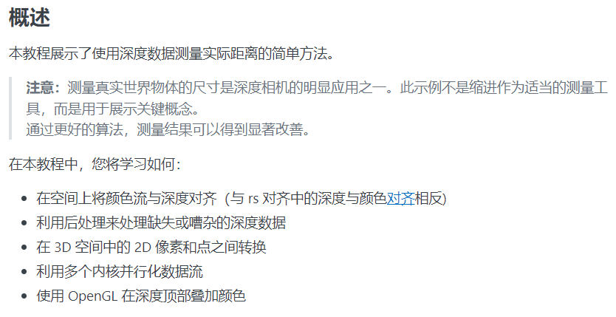

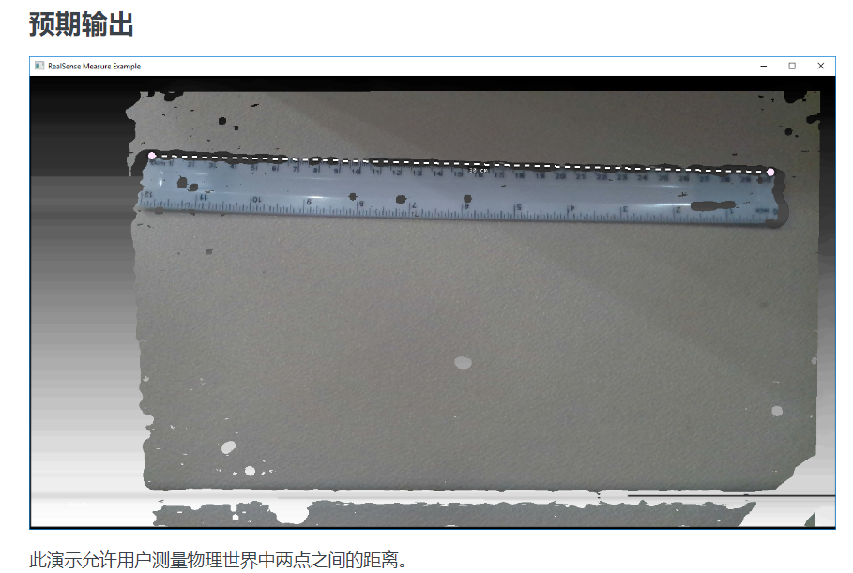

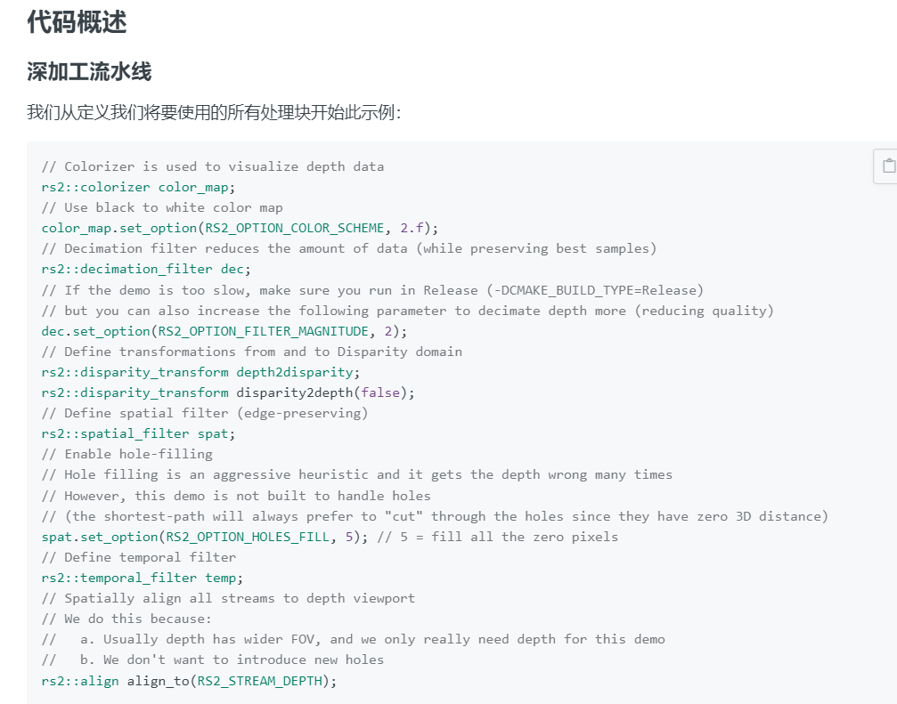

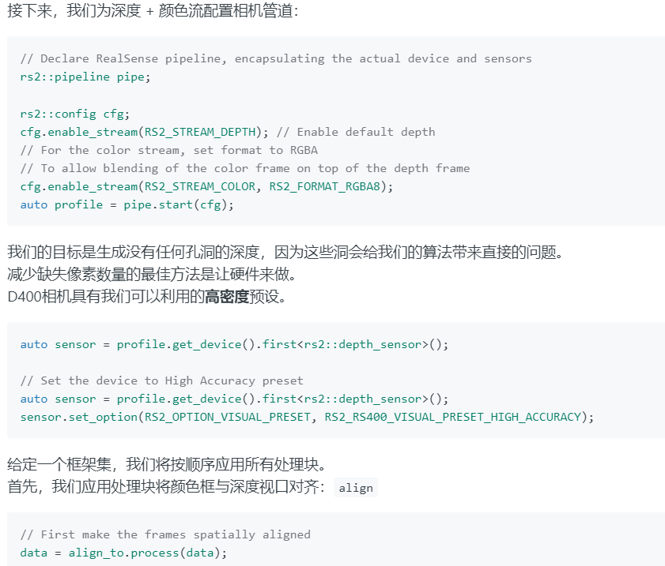

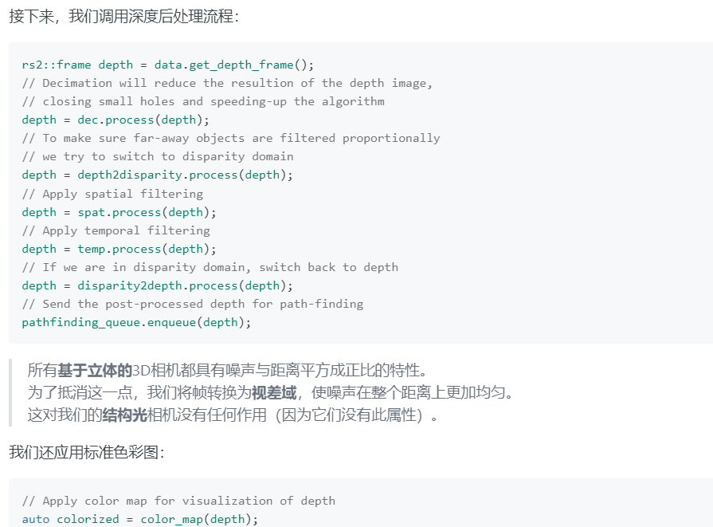

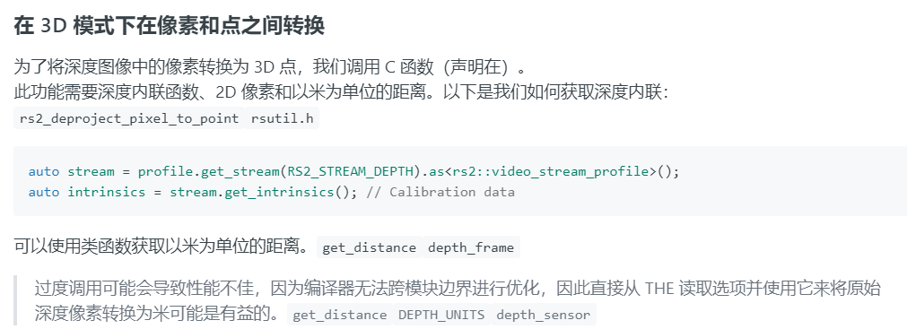

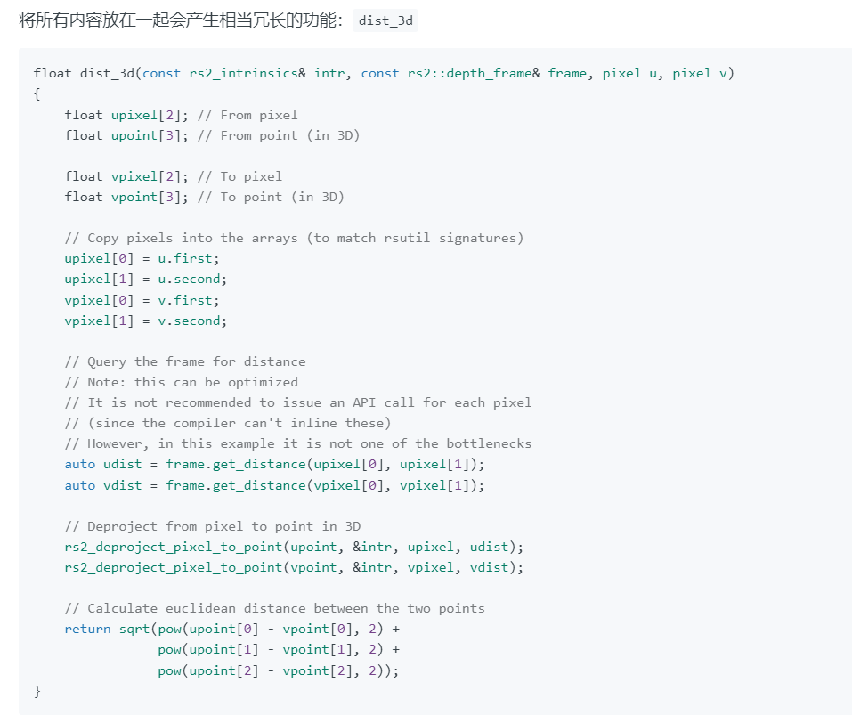

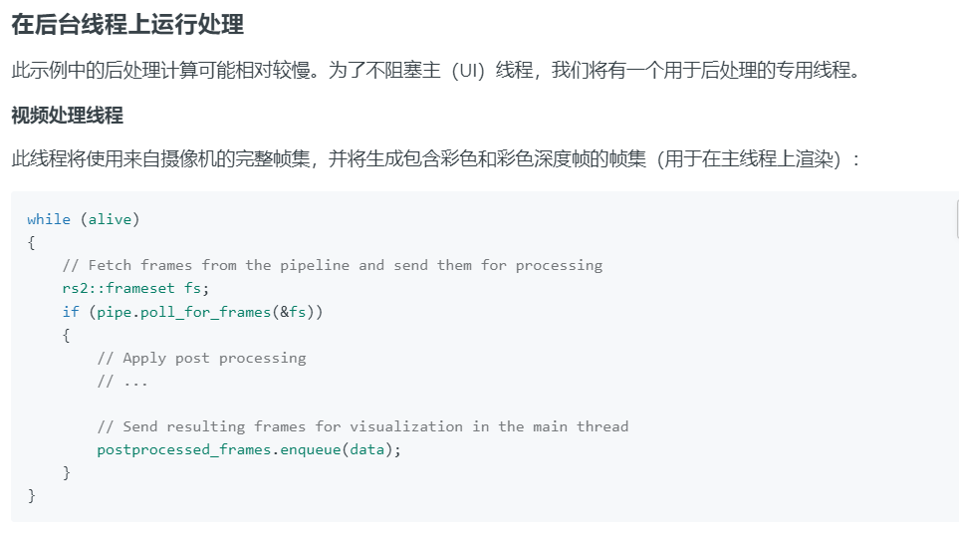

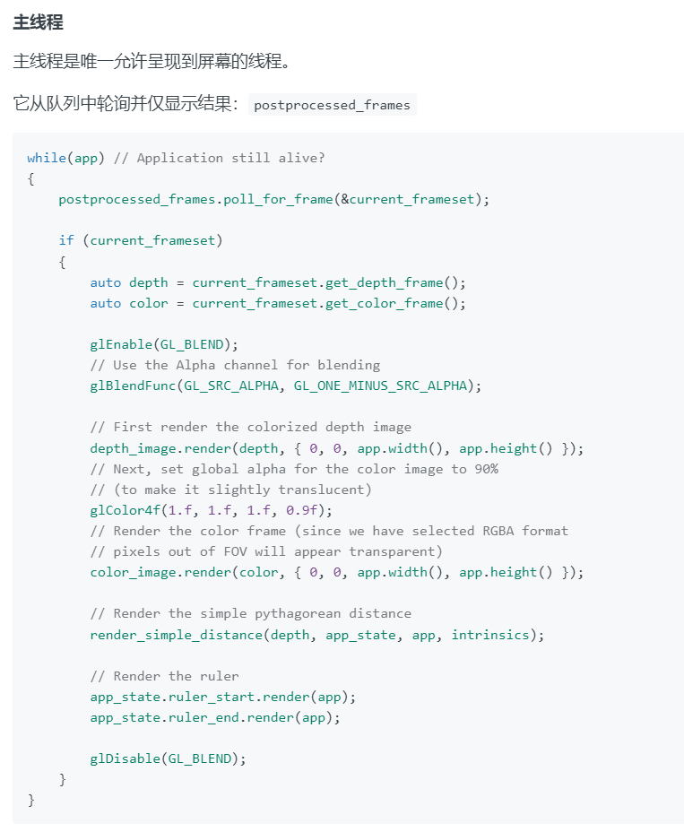

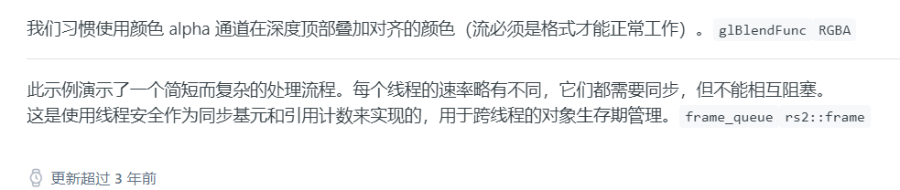

# 10、rs-post-processing

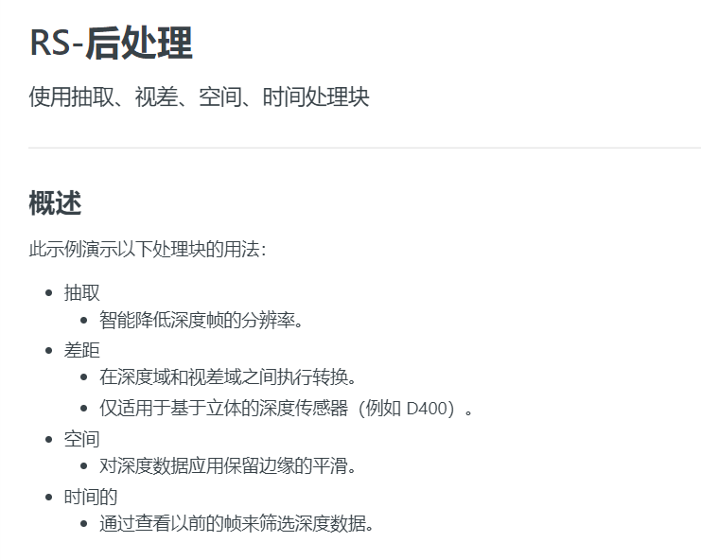

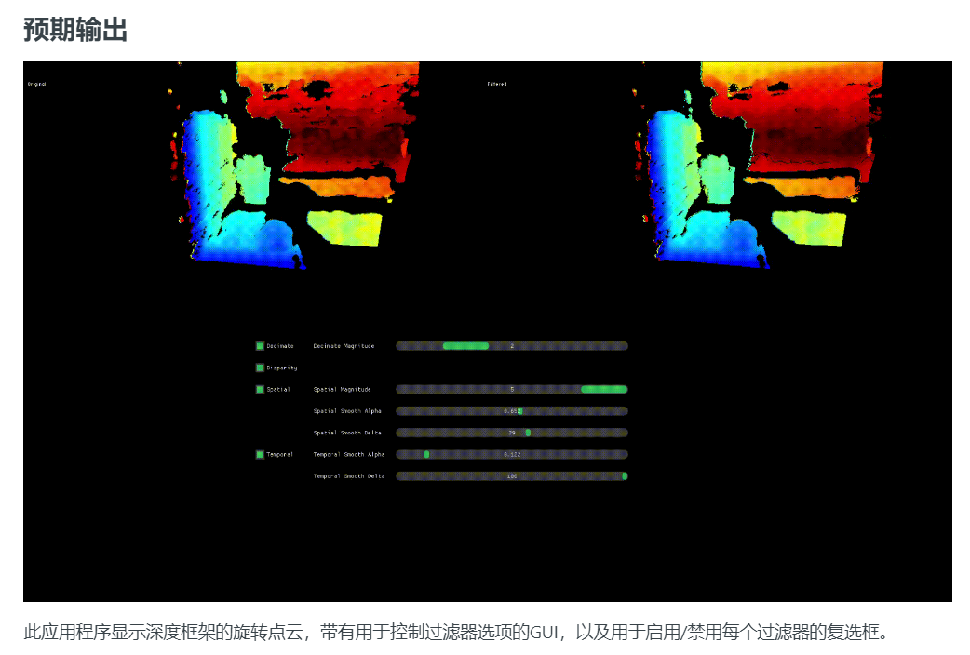

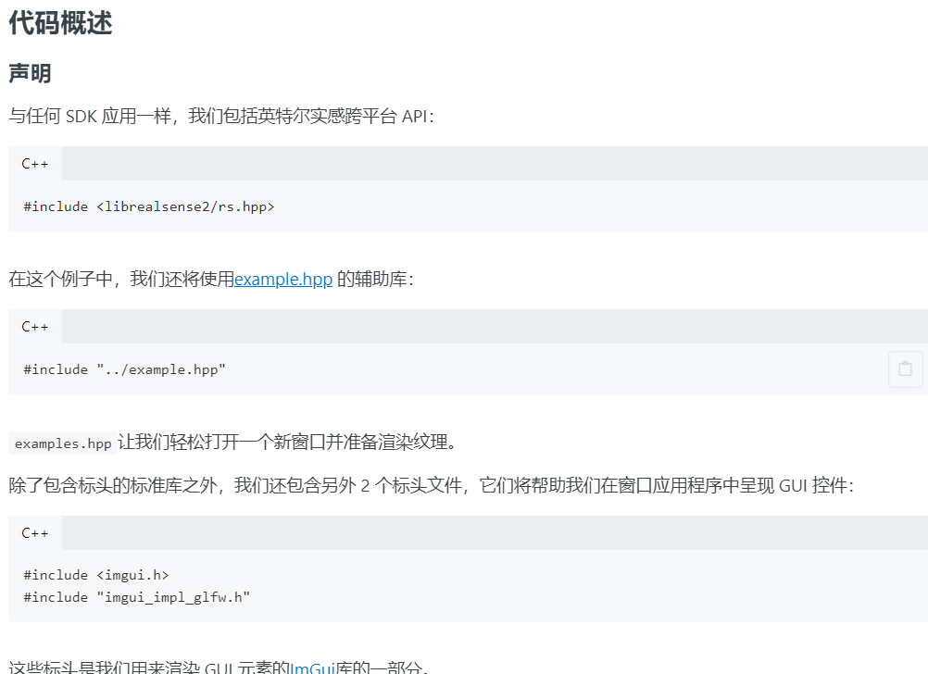

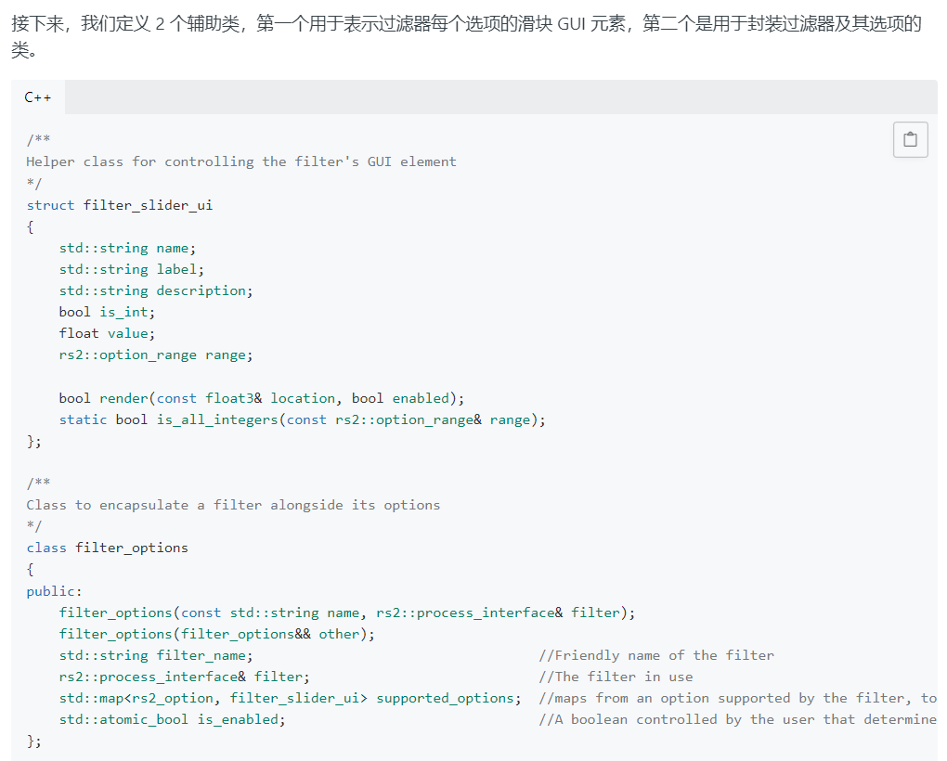

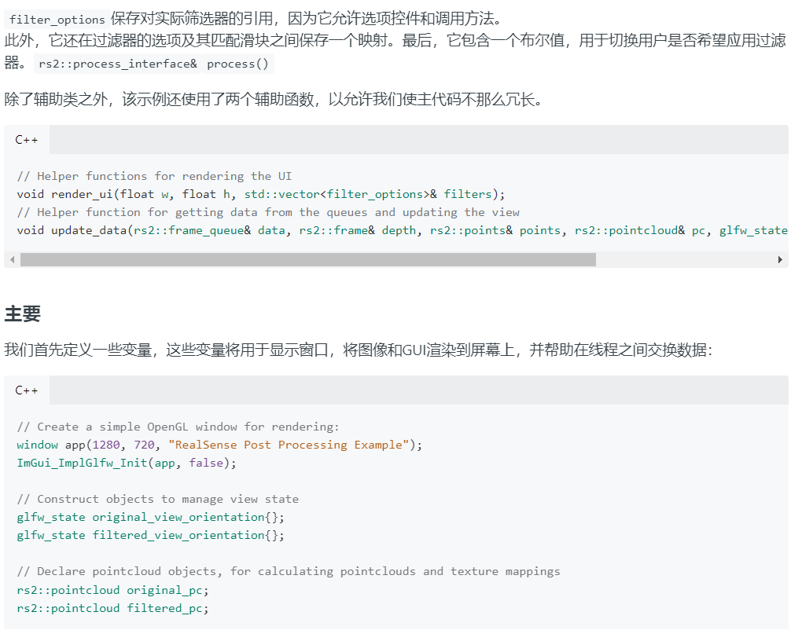

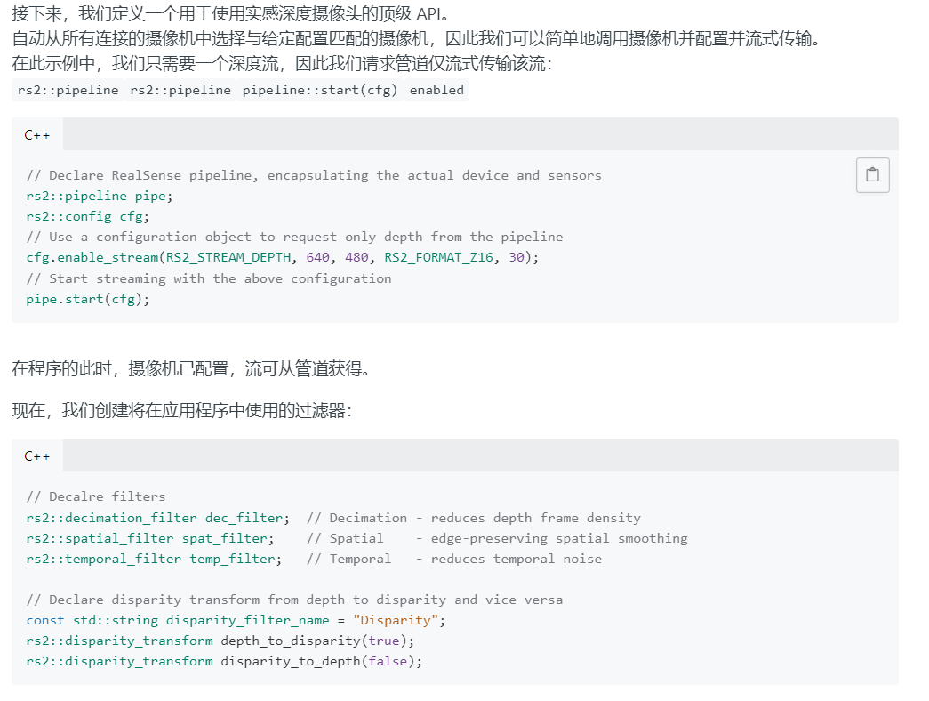

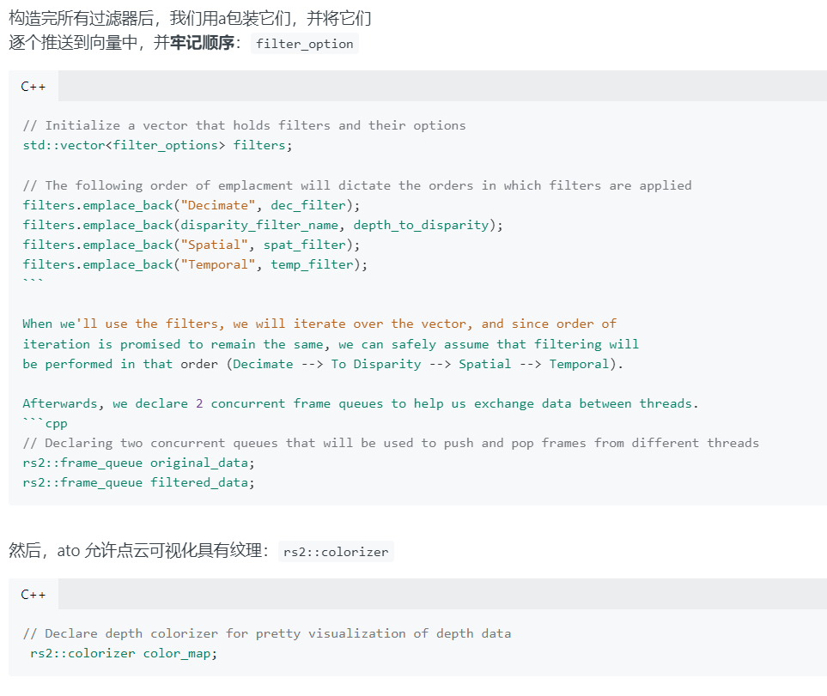

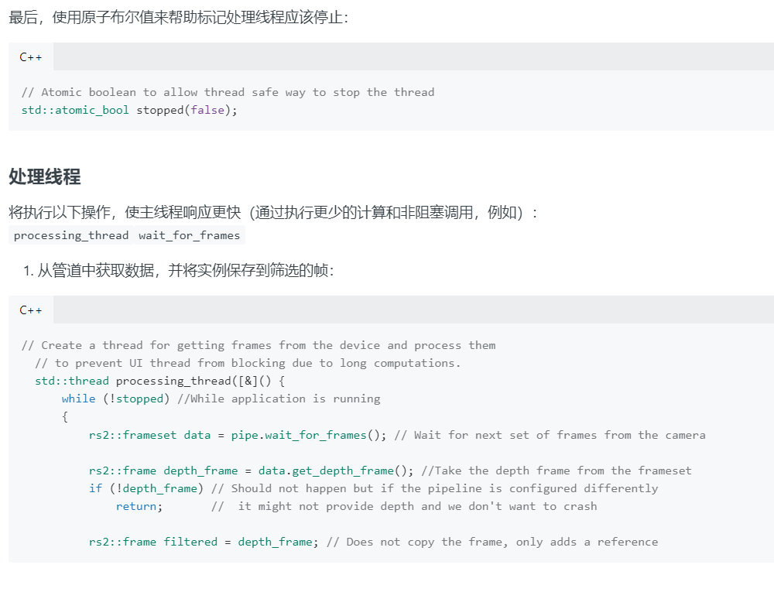

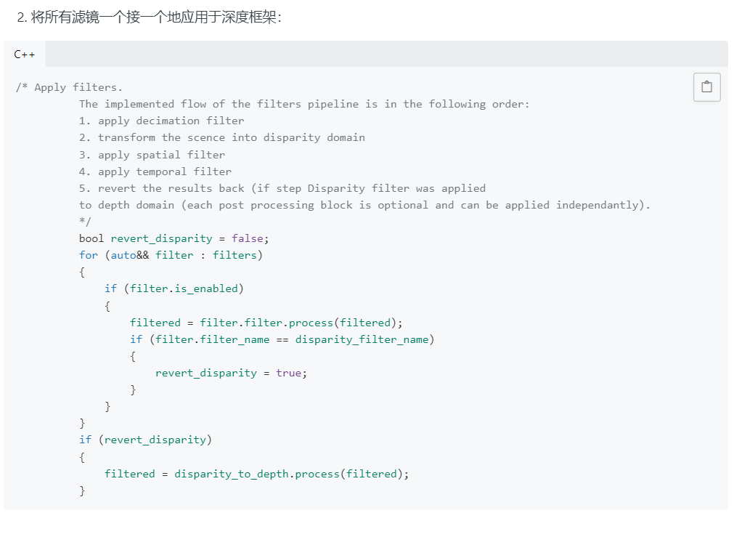

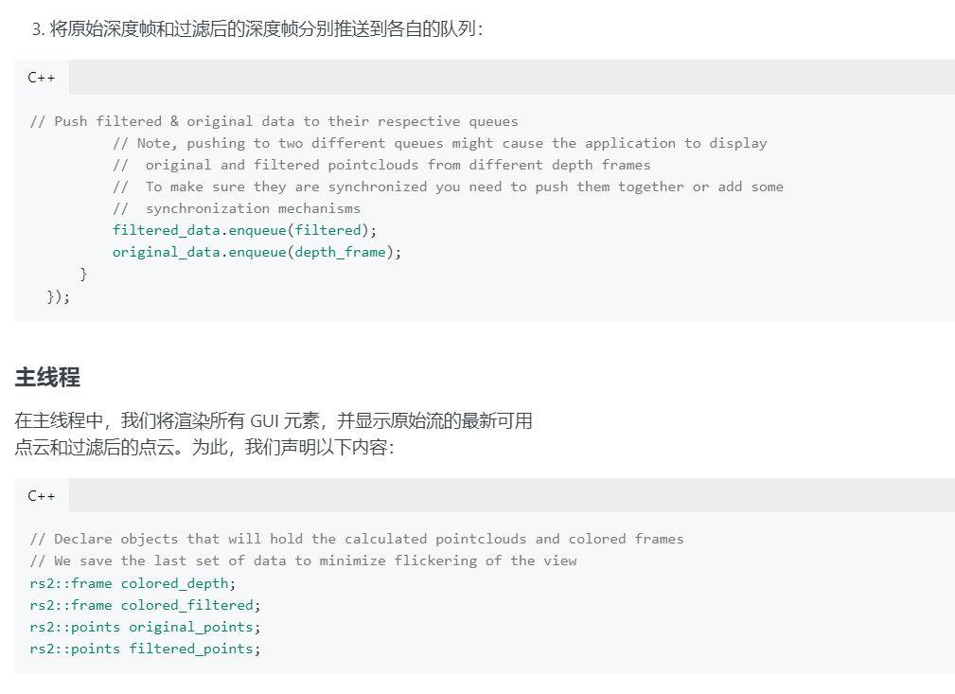

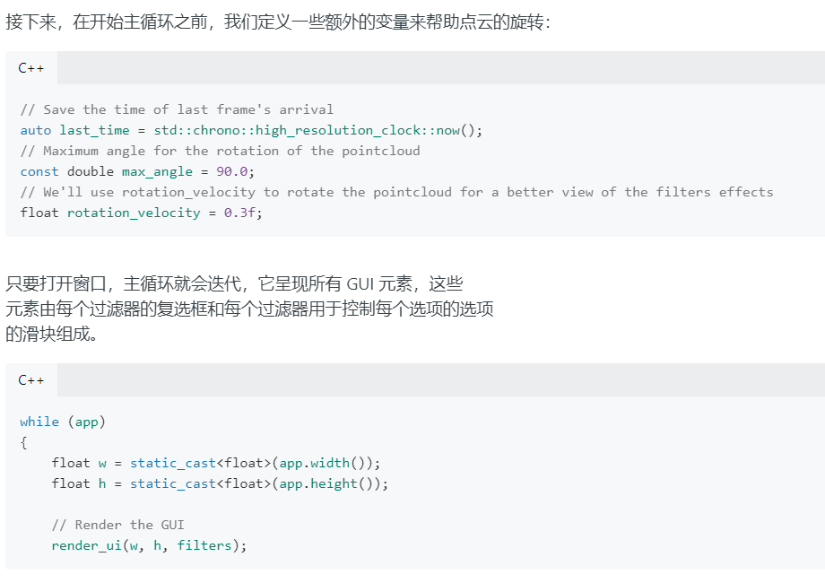

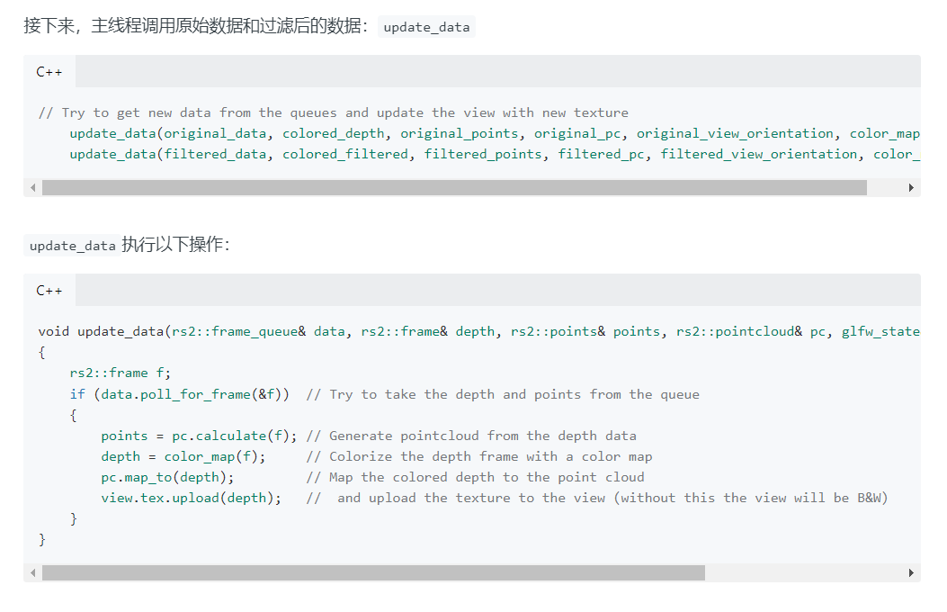

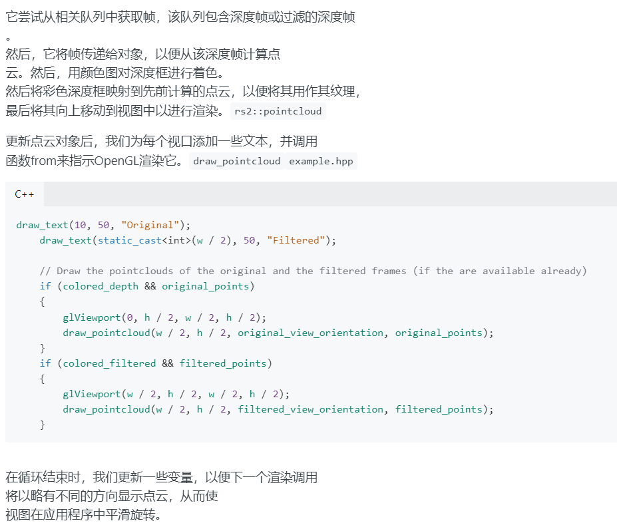

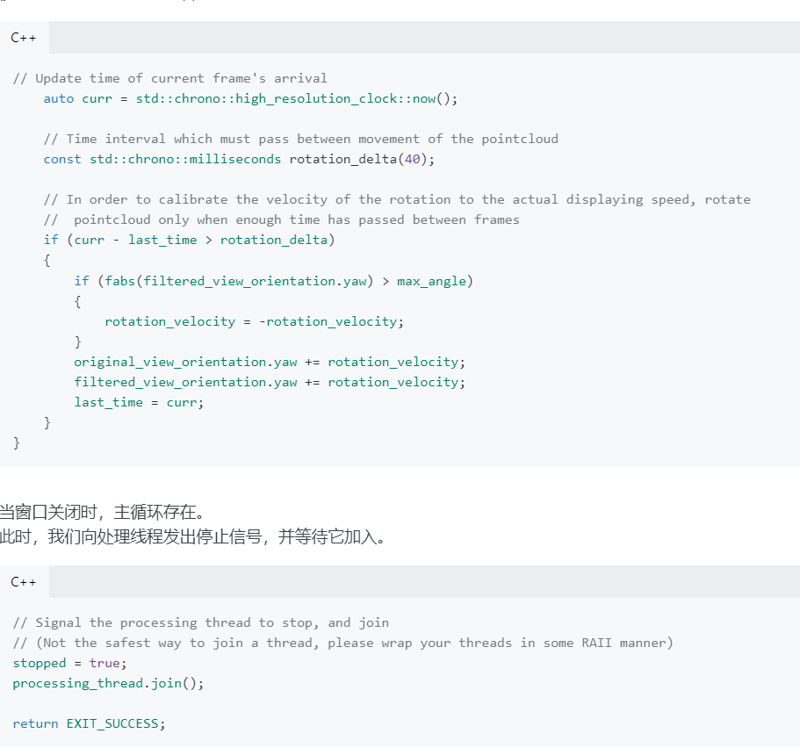

# 重要：12、rs-motion

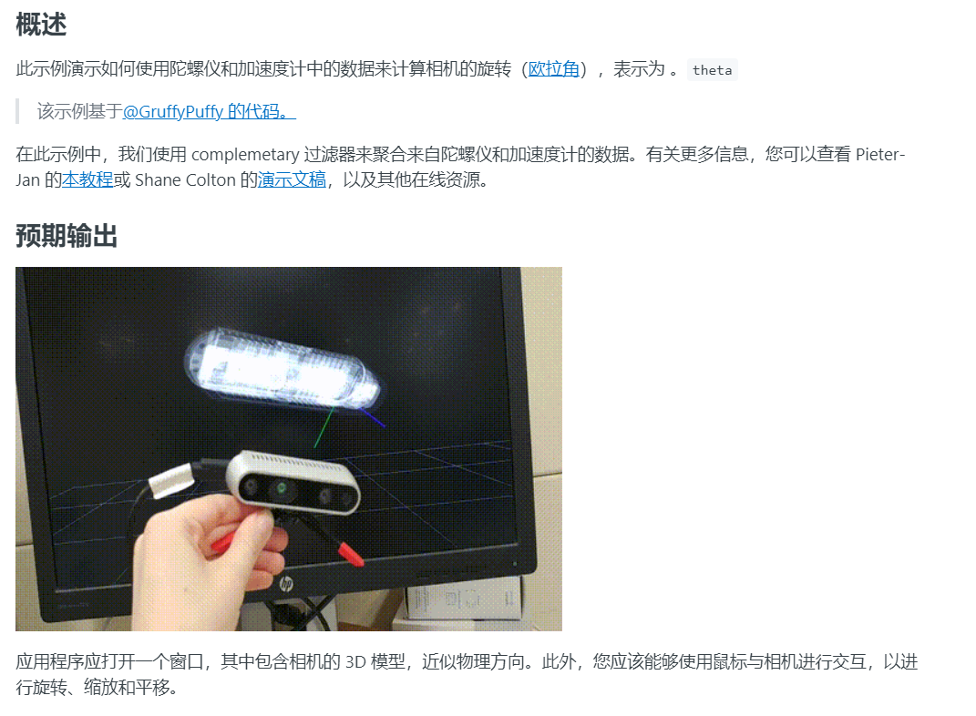

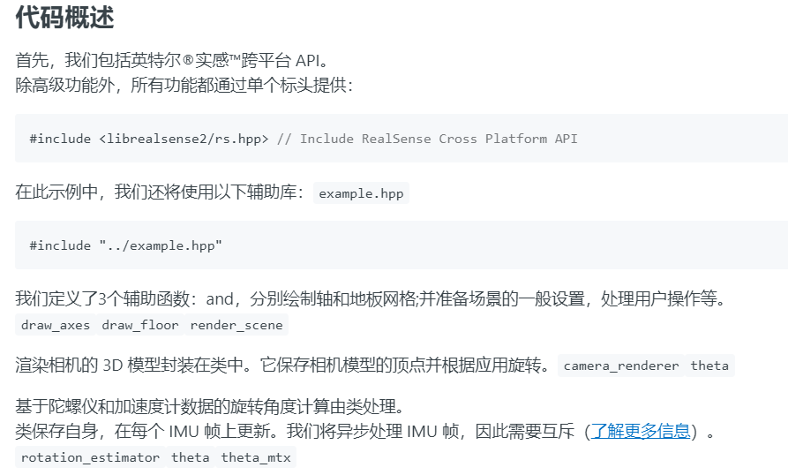

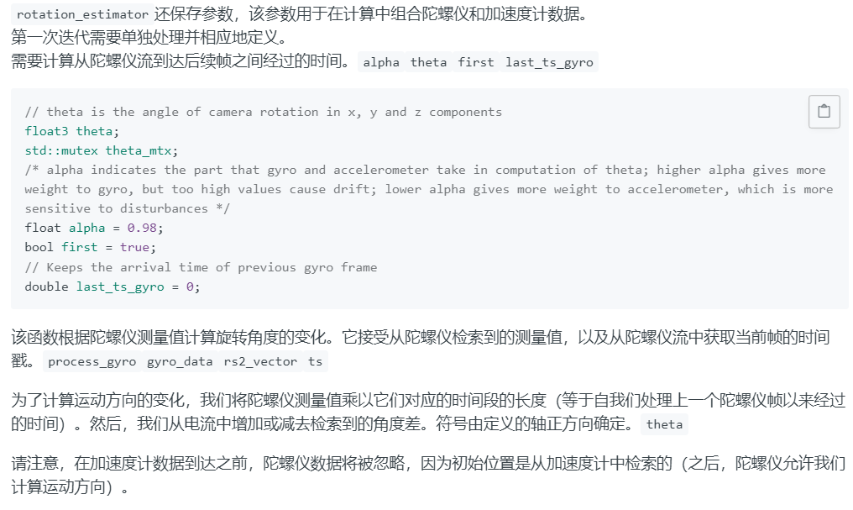

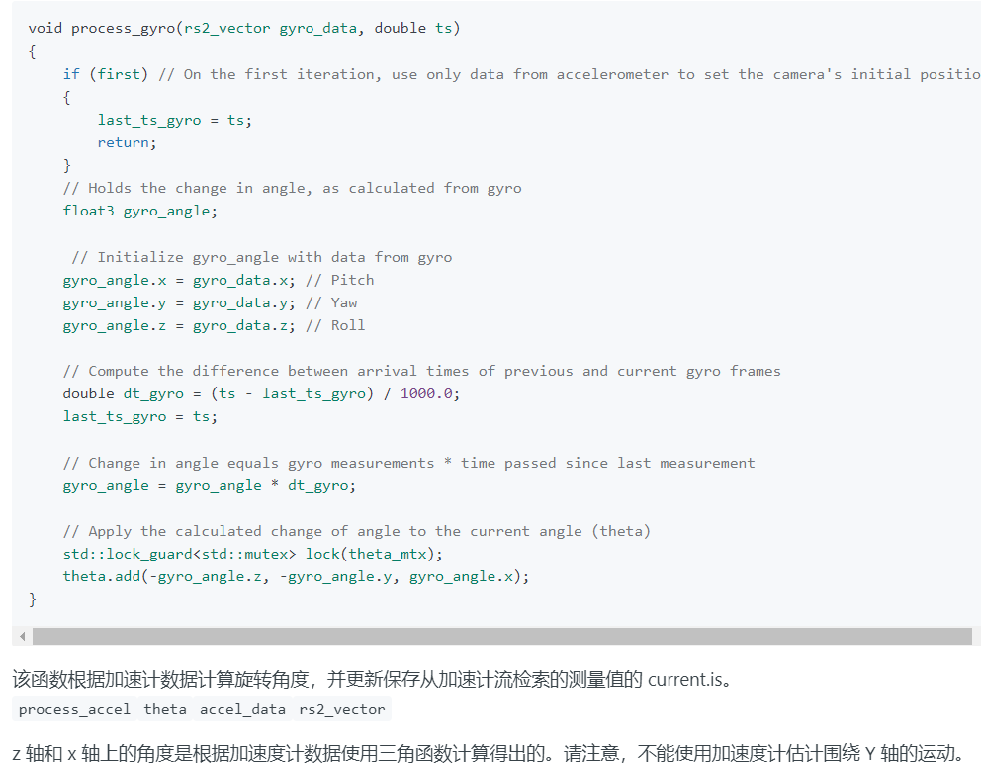

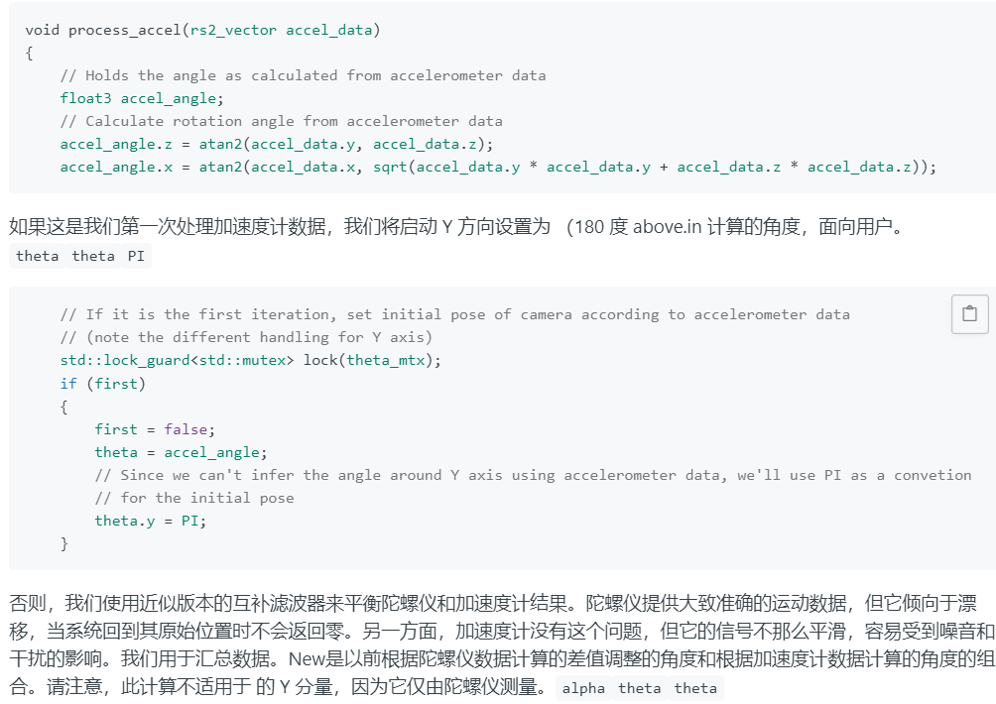

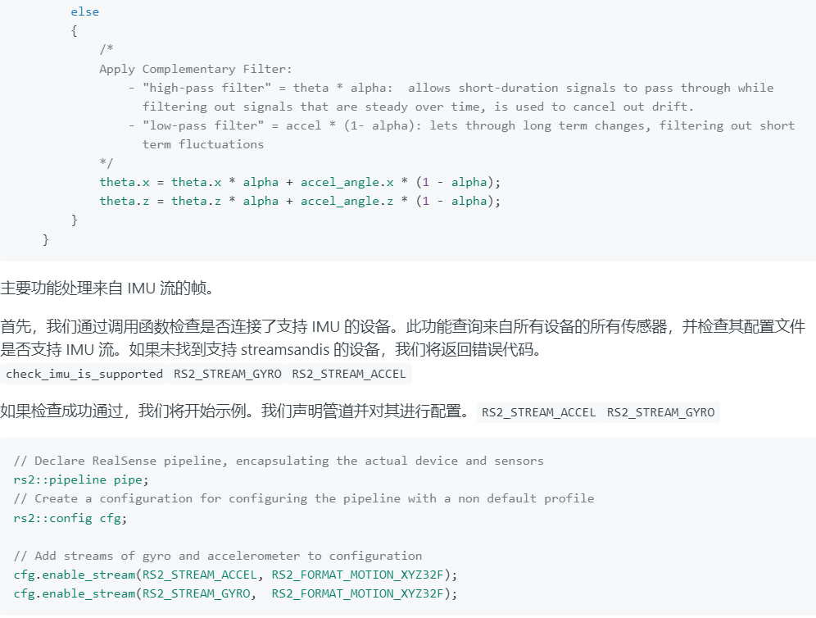

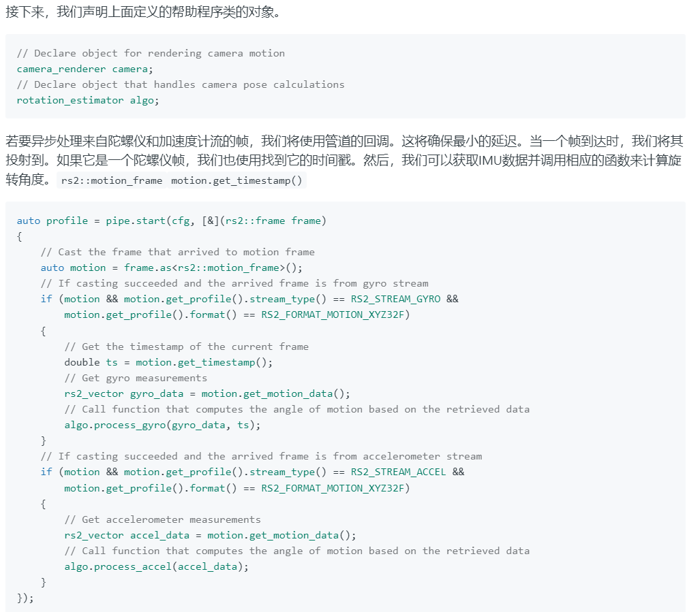

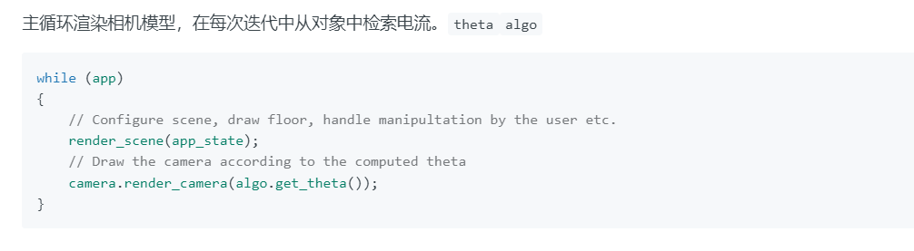

# 13、rs-record-playback

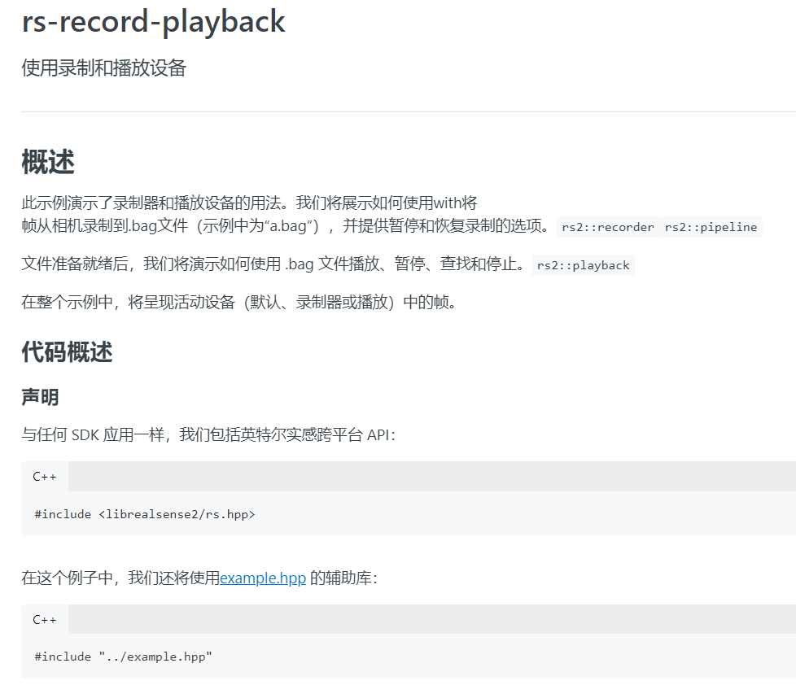

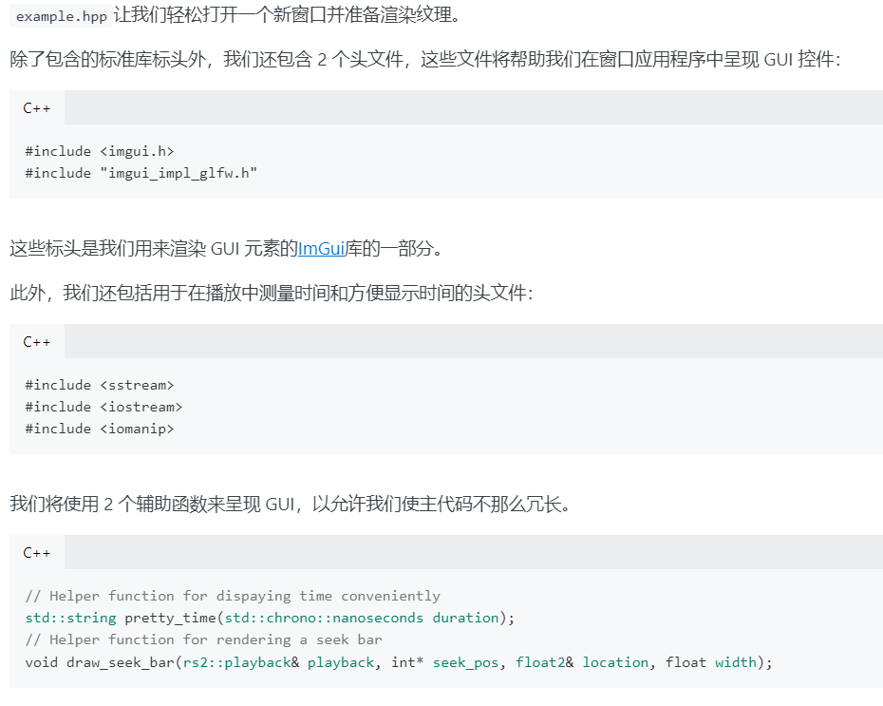

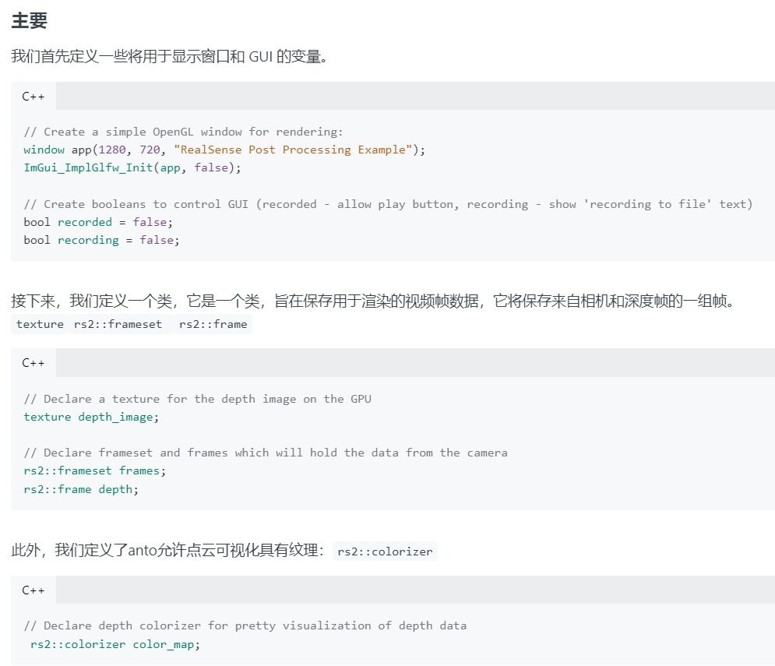

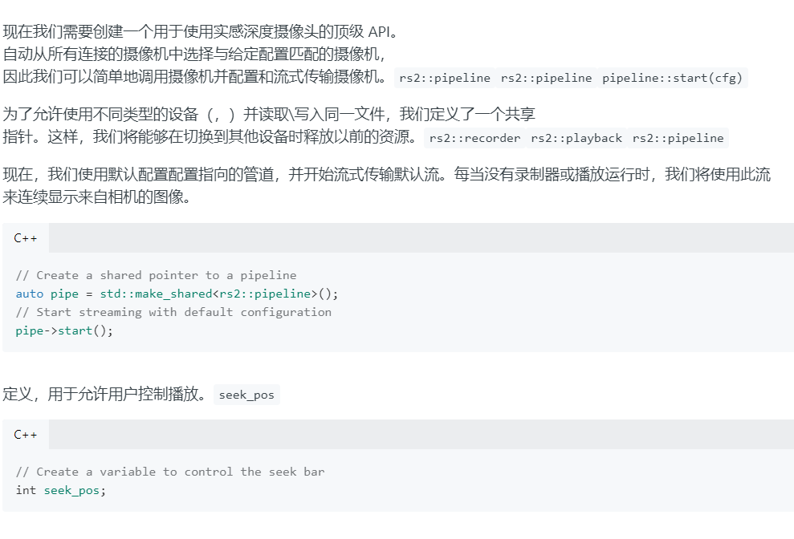

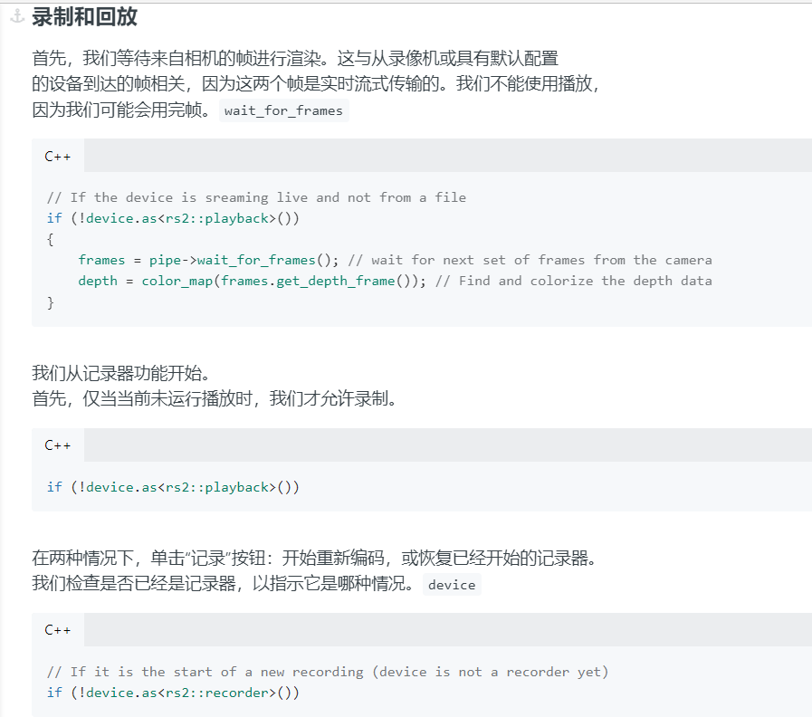

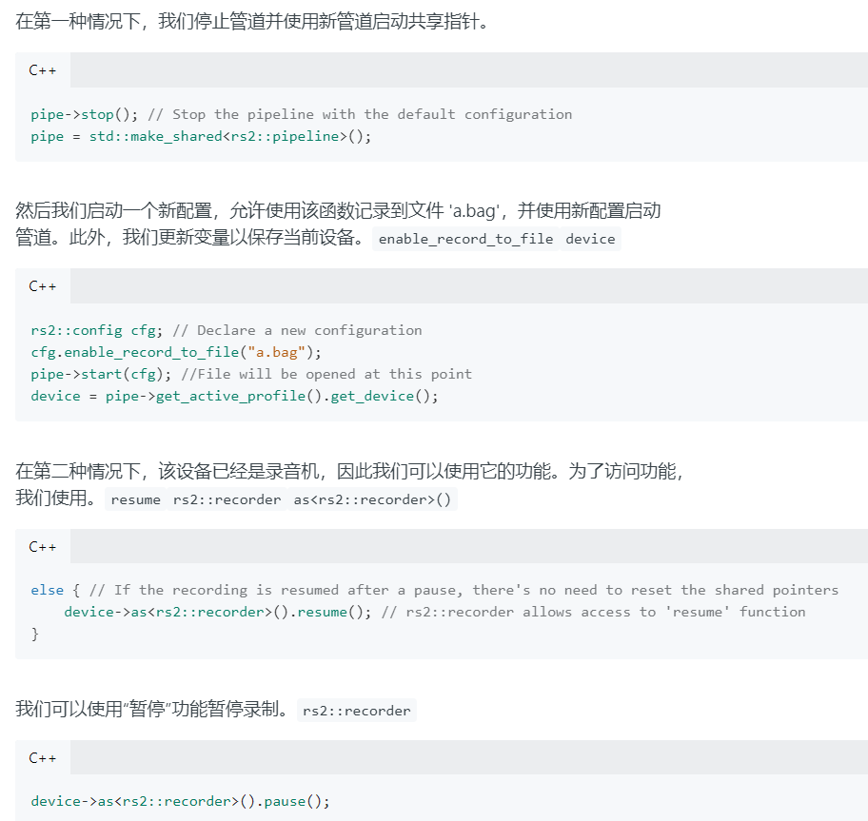

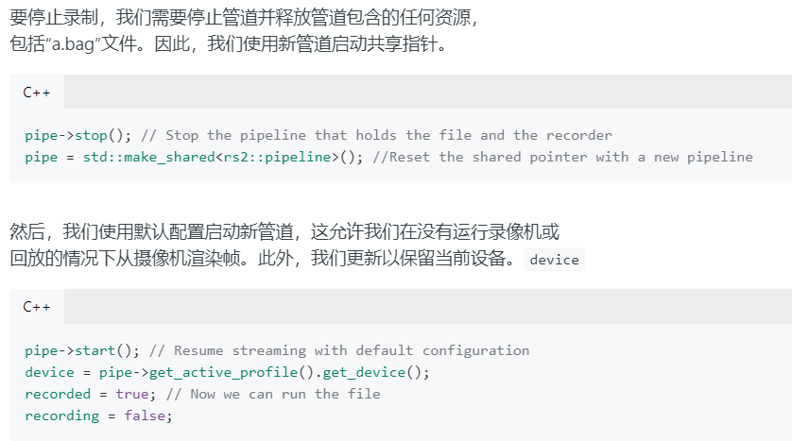

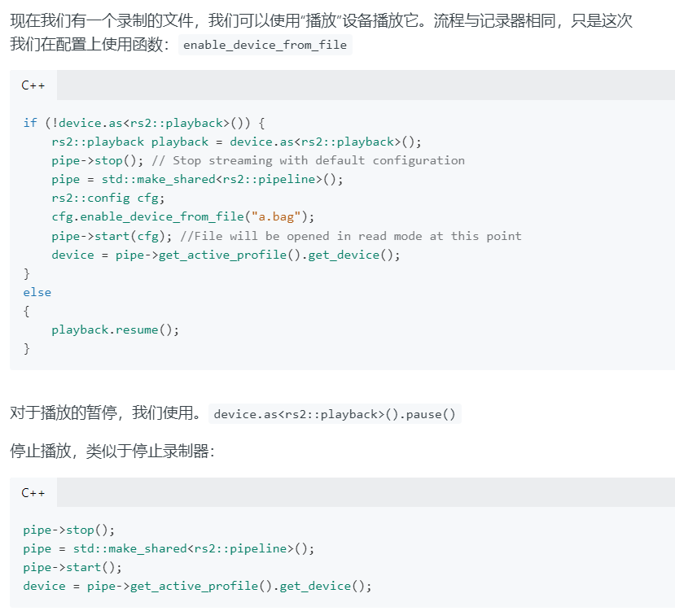

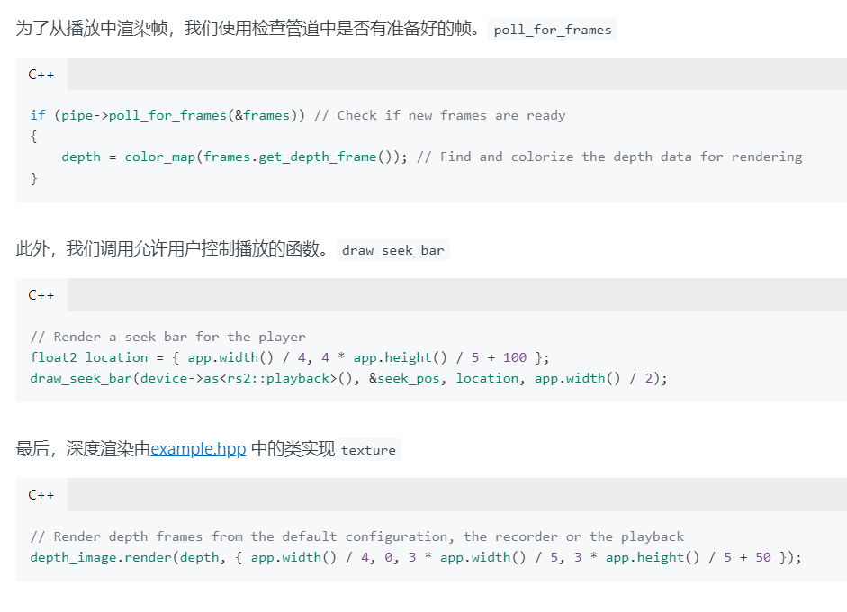

Maybe:可行的预测姿势方案？

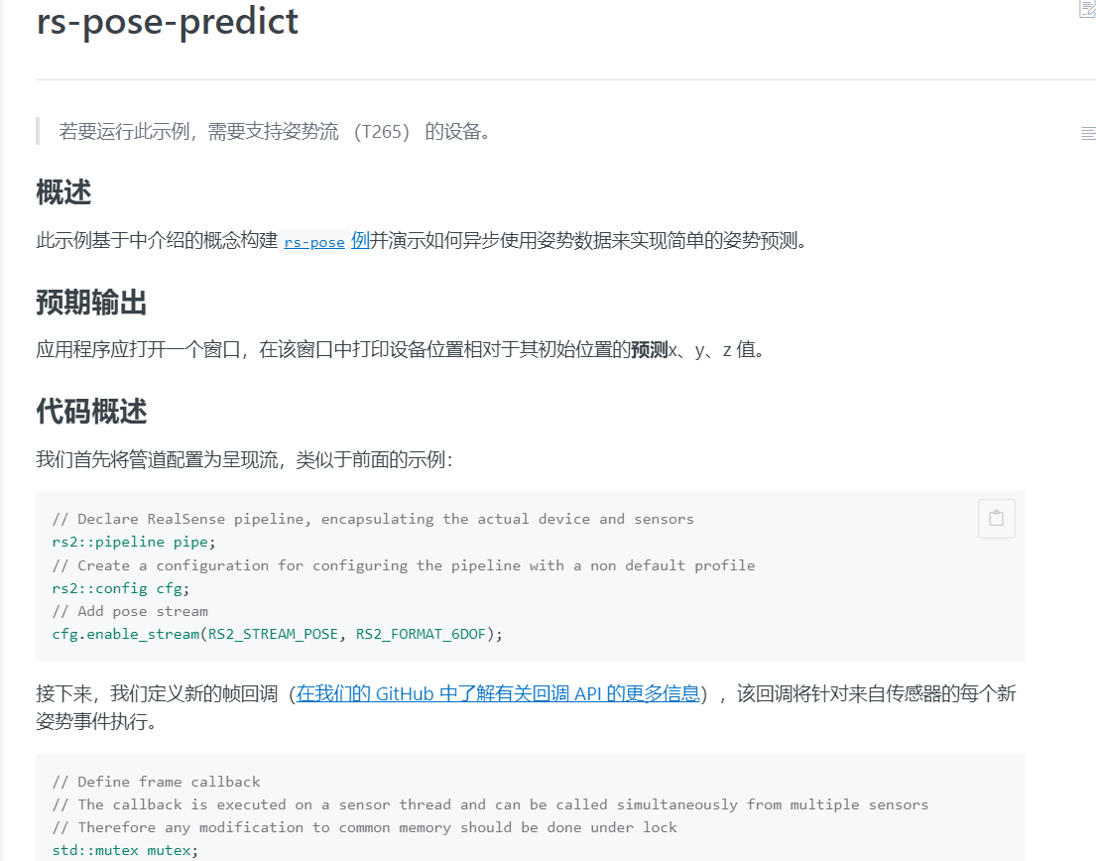

# 14、rs-sensor-control

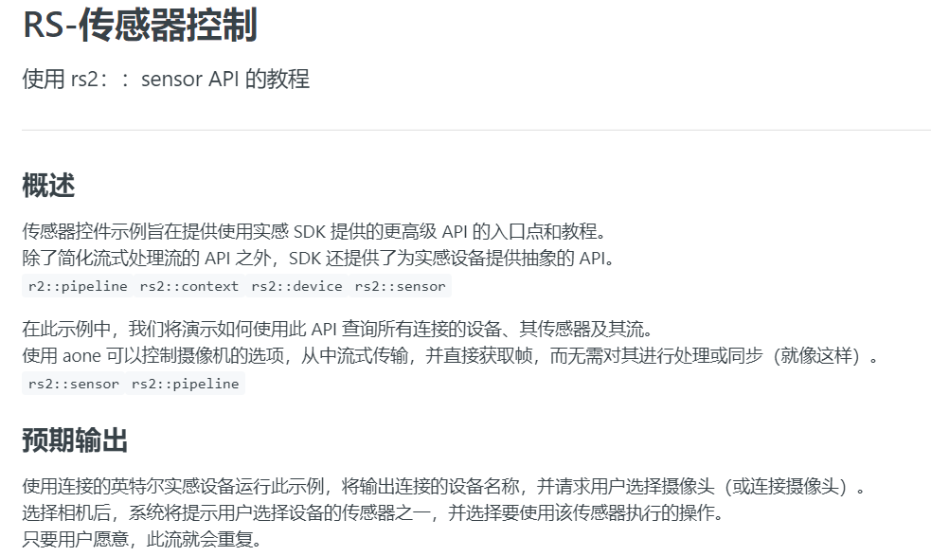

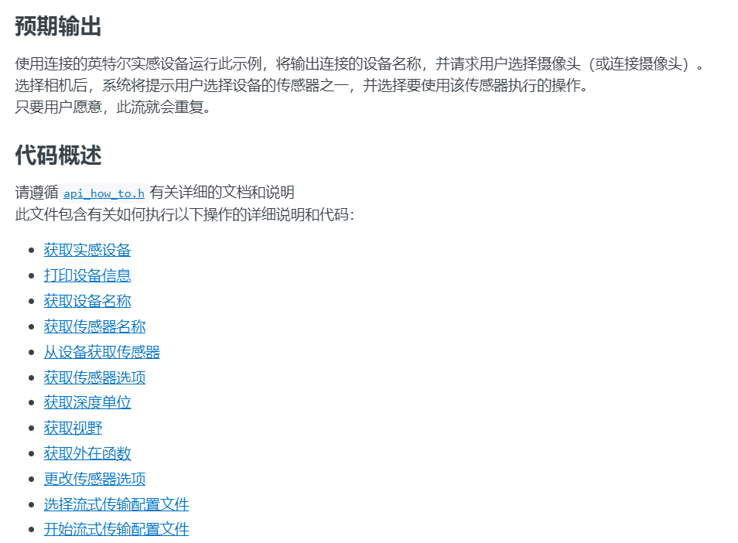

[librealsense/api_how_to.h at master · IntelRealSense/librealsense · GitHub](https://github.com/IntelRealSense/librealsense/blob/master/examples/sensor-control/api_how_to.h)

# 14、rs-grabcuts

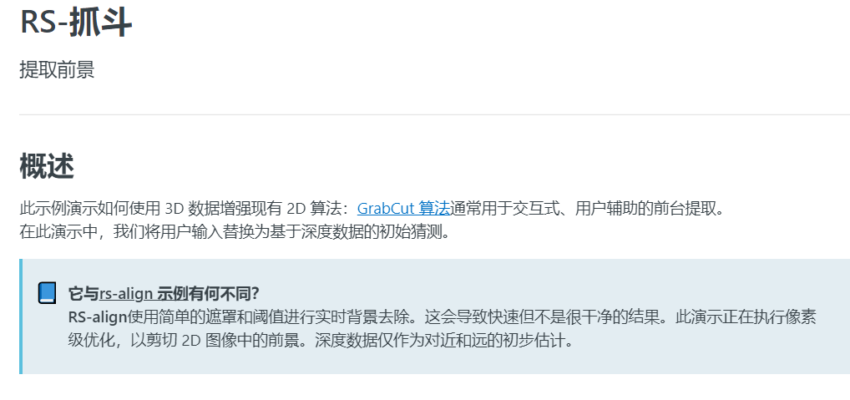

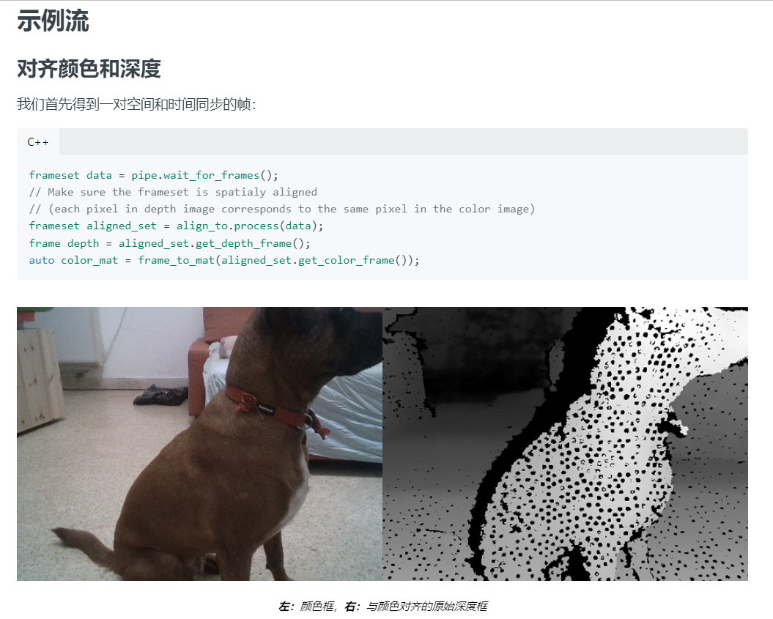

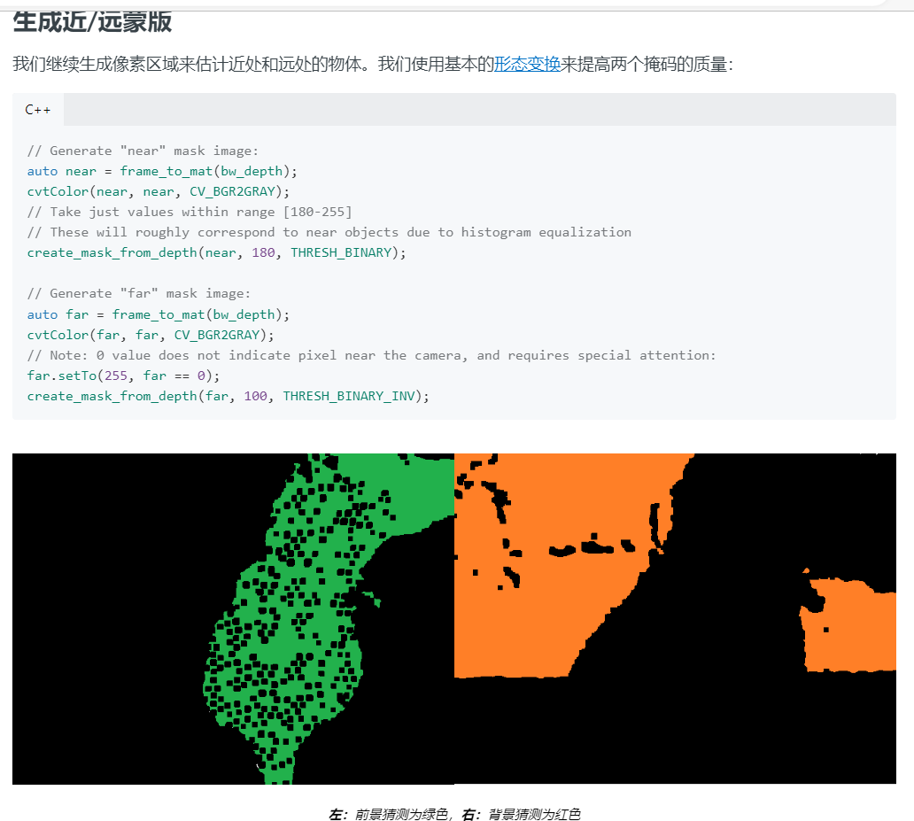

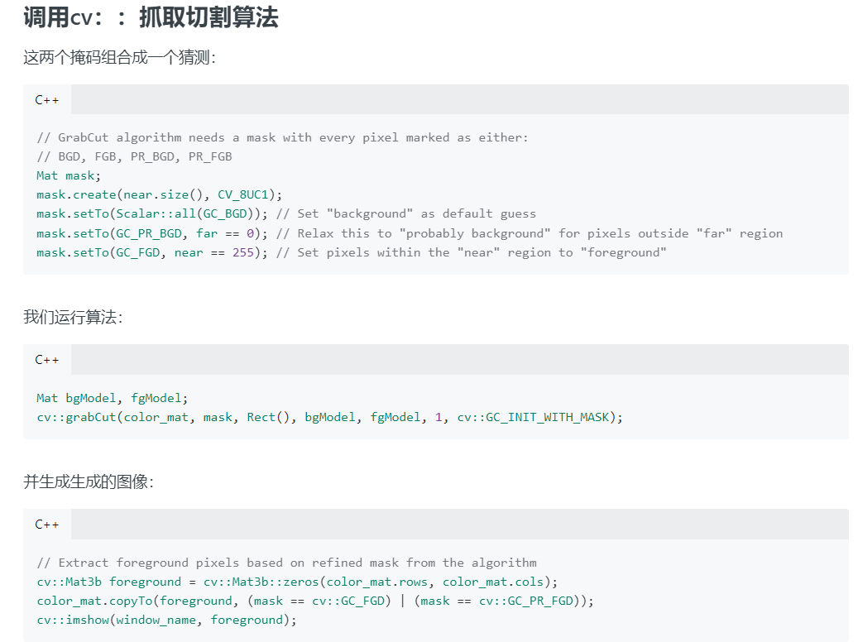

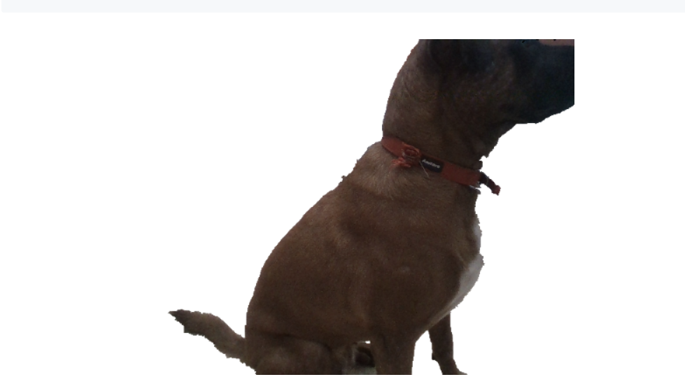

16、opencv

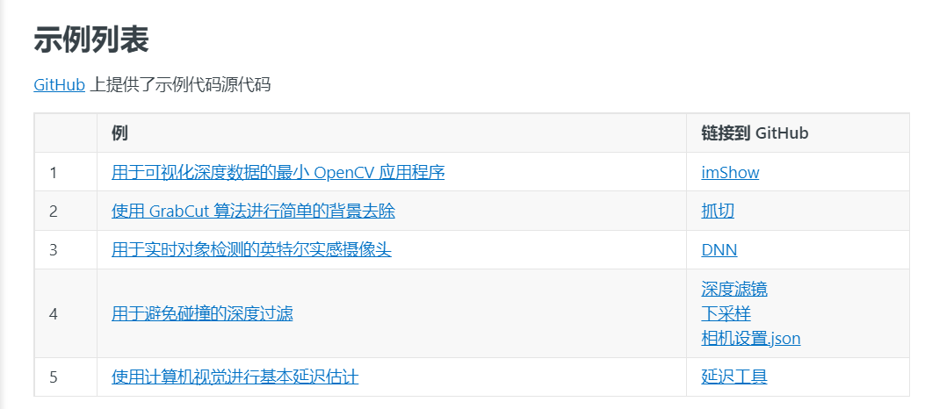

s

**SDK2.0 使用**

[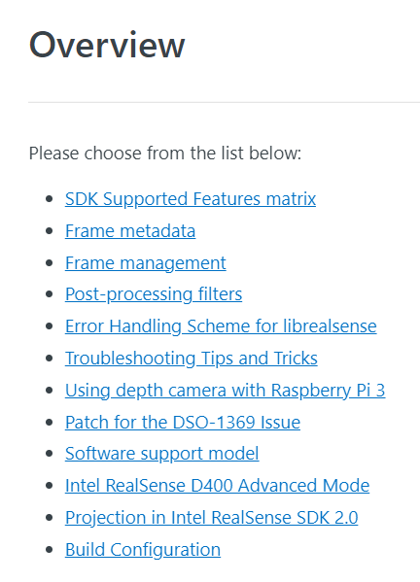Intel RealSense Documentation - Get Started](https://dev.intelrealsense.com/docs?_ga=2.20933560.1000067668.1668085220-1863511277.1668085220)



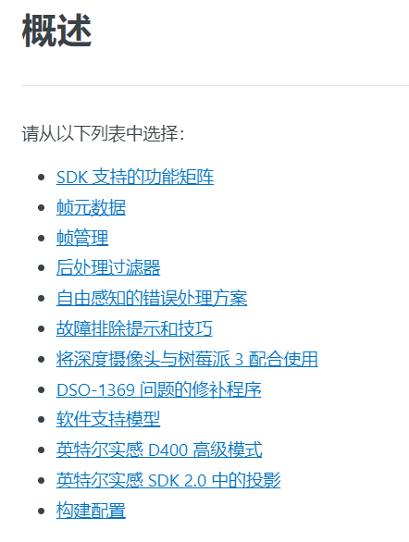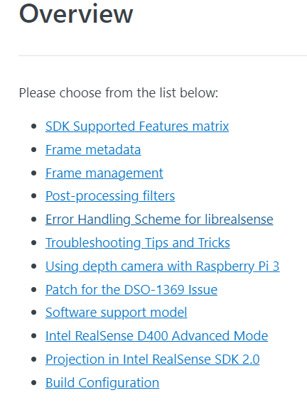



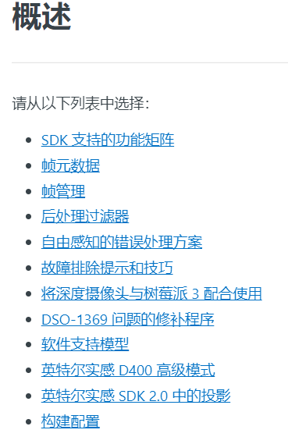

**英特尔实感 SDK 2.0 API**

[Overview (intelrealsense.com)](https://dev.intelrealsense.com/docs/api)

# API 操作方法

[API How-To (intelrealsense.com)](https://dev.intelrealsense.com/docs/api-how-to)

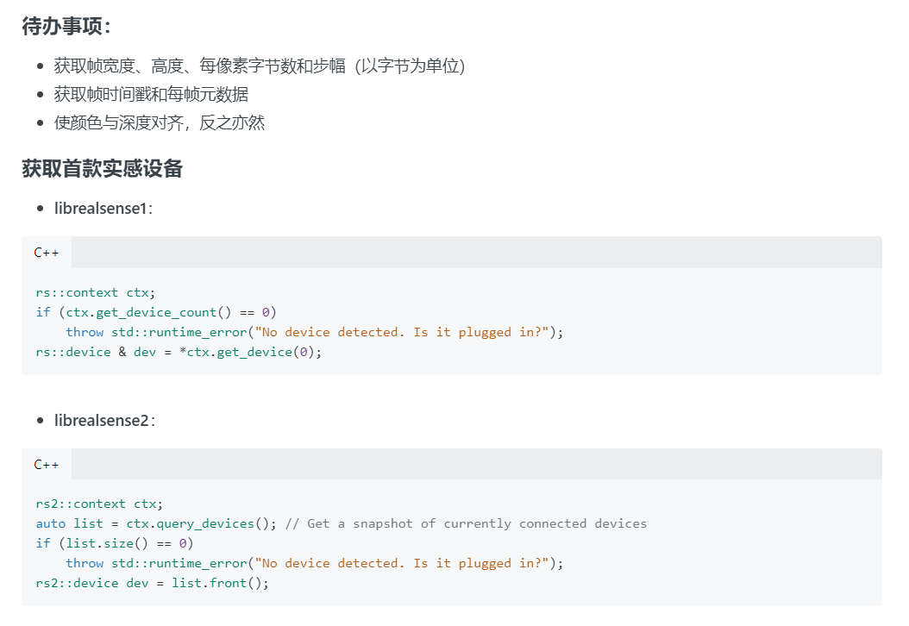

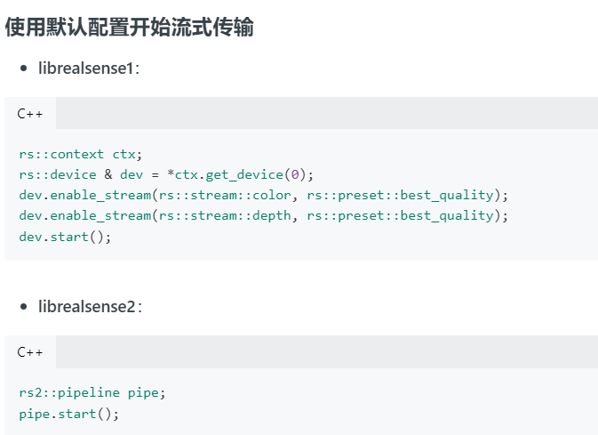

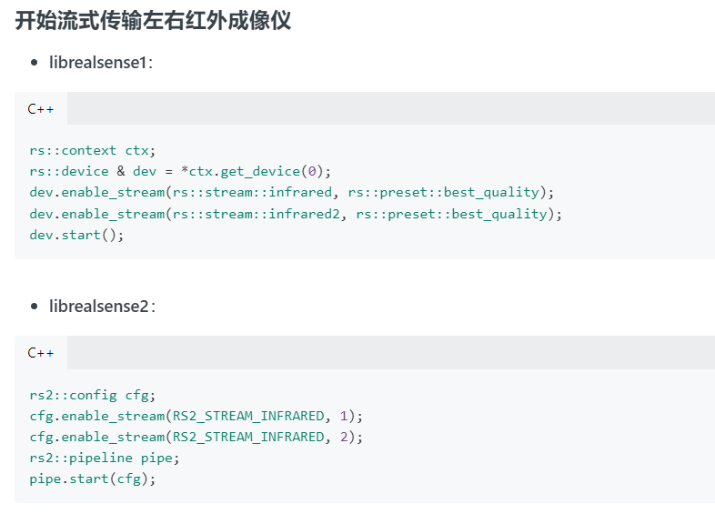

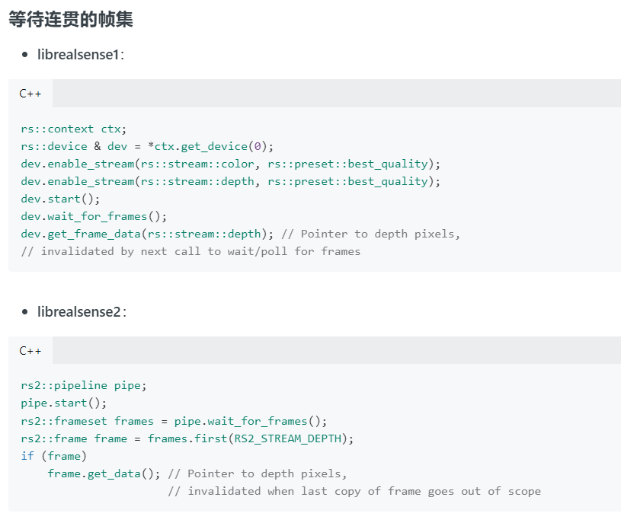

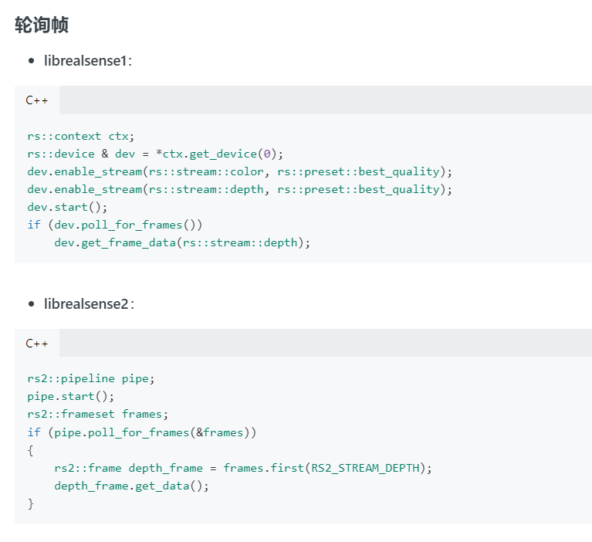

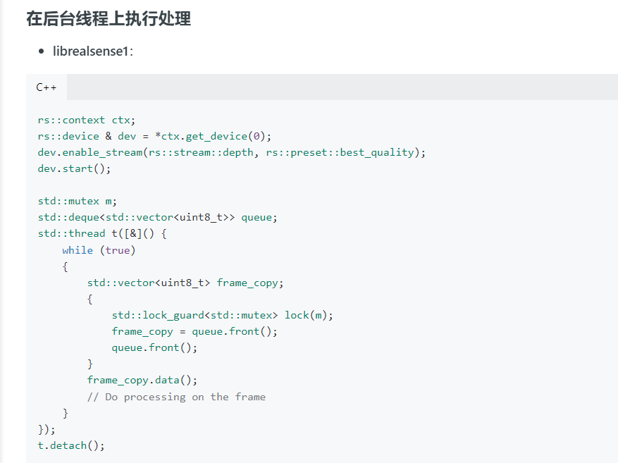

rs::context ctx;

rs::device & dev = *ctx.get_device(0);

dev.enable_stream(rs::stream::depth, rs::preset::best_quality);

dev.start();

std::mutex m;

std::deque<std::vector<uint8_t>> queue;

std::thread t([&]() {

while (true)

{

std::vector<uint8_t> frame_copy;

{

std::lock_guard<std::mutex> lock(m);

frame_copy = queue.front();

queue.front();

}

frame_copy.data();

// Do processing on the frame

}

});

t.detach();

while (true)

{

dev.wait_for_frames();

const auto stream = rs::stream::depth;

const auto CAPACITY = 5; // allow max latency of 5 frames

uint8_t bytes_per_pixel = 1;

switch (dev.get_stream_format(stream))

{

case rs::format::raw8:

case rs::format::y8:

bytes_per_pixel = 1;

break;

case rs::format::z16:

case rs::format::disparity16:

case rs::format::yuyv:

case rs::format::y16:

case rs::format::raw10:

case rs::format::raw16:

bytes_per_pixel = 2;

break;

case rs::format::rgb8:

case rs::format::bgr8:

bytes_per_pixel = 3;

break;

case rs::format::rgba8:

case rs::format::bgra8:

case rs::format::xyz32f:

bytes_per_pixel = 4;

break;

}

auto ptr = (uint8_t*)dev.get_frame_data(rs::stream::depth);

std::vector<uint8_t> frame_copy( // Deep-copy the frame data

ptr, ptr + dev.get_stream_width(stream) *

dev.get_stream_height(stream) *

bytes_per_pixel);

{

std::lock_guard<std::mutex> lock(m);

if (queue.size() < CAPACITY)

queue.push_back(frame_copy);

}

}

